Chapter 10 BLM Answers

BLM 10–2 Patterns and Expressions
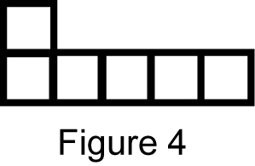
1. a)

b)
  Figure Number | 1 | 2 | 3 | 4 | 5
  Number of Squares | 3 | 4 | 5 | 6 | 7
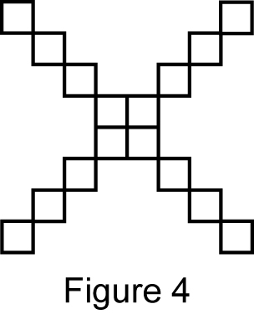
2.

Answers may vary. For example: Each
figure has four more squares than the previous figure.
3.
  Figure Number | 1 | 2 | 3 | 4
  Number of People | 4 | 7 | 10 | 13
4. a) 11
b) Multiply the figure number by 3 and
subtract 1 to get the number of
triangles.
5. a) T b) (3, 0) c) P and R
d) PRT, RST, RSU, QSU, and QST

BLM 10–4 Section 10.1 Extra Practice
1. a) 15, b) 621,
c) 007, d) 842,
2. a) 0.1350135013501350…,
b) 0.02252252252252…,
c) 0.76623376623376623…,
d) 0.285714285714285714…,
3. a) b) c)
4. a) Add . b) Add .
c) ,
BLM 10–7 Section 10.2 Extra Practice
1.
Expression | Variable | Numerical Coefficient | Constant
a) | x | 4 | 9
b) | a | 3 | 7
c) | b | 2 | 12
d) | w |  | 10
e) | y | 6
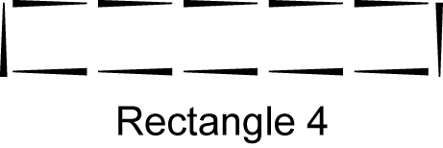
2. a)

b)
  Rectangle | Perimeter (P)
  1 | 6
  2 | 8
  3 | 10
  4 | 12
c) 24
d) where r is the rectangle
number

BLM 10–9 Section 10.3 Extra Practice
1. a) 3c + 3 b) 5c − 4
c) 7c + 1 + 1 or 7c + 2
2. a) 4(3) + 3 = 12 + 3 = 15
b) 4(5) + 3 = 20 + 3 = 23
c) 4(10) + 3 = 40 + 3 = 43
3. a) 7 + 3(7) = 7 + 21 = 28
b)
c) 10 − 4(0) = 10 − 0 = 10
d)
4. a)
  Number  of Rows | Number  of Chairs
  4 | 40
  5 | 50
b) 90 c) 10r
d) There are the same number of chairs in each row.

BLM 10–11 Section 10.4 Extra Practice
1. a) The y-coordinate is the x-coordinate
divided by 10. (x, ) or
b) The y-coordinate is the x-coordinate
multiplied by 2 plus 1.
(x, or
2.
  Number of Games (g) | Total Cost  (C) in Dollars
  2 | 40
  3 | 45
  4 | 50
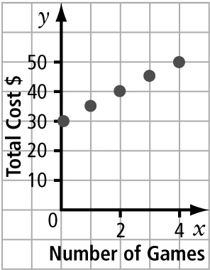
b)

c) C = 5g + 30

BLM 10–13 Chapter 10 Test
1. E variable
2. D numerical coefficient
3. B expression
4. C constant
5. D 6. C 7. D 8. B 9.
10. a)
b) The cost of five pizzas is $45.
11. a) The cabin has 14 doors.
b) 3r  1 where r is the number of
rooms
12. a)
  x | y
  2 | 3
  3 | 5
  4 | 7
  5 | 9
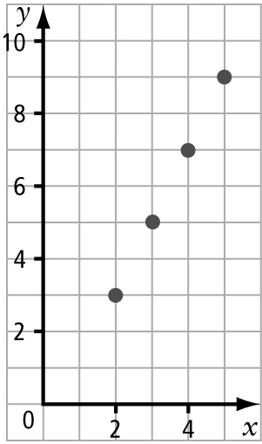
b)

c) Josie and Sam are each buying a bottle of pop. They have a coupon that takes $1 off of the total cost. The cost of each bottle of pop is x. The total amount they have to
pay is y.

