Chapter 11 Self-Assessment
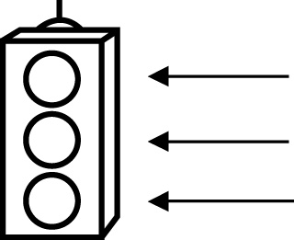 | RED I have not started moving in this area.  YELLOW I am moving along with caution in this area.  GREEN I am moving along confidently in this area.

BEFORE | DURING  (What I can do if I mark yellow or red.) | AFTER  (Proof that I can do this.)
11.1

I can identify constants, coefficients, and variables in
expressions and
equations.
I can describe the difference between an expression and an
equation.
11.2
I can model problems with equations.
I can solve equations and record the process.
I can verify solutions to equations.
11.3
I can model problems with equations.
I can solve equations and record the process.

11.4
I can model problems with two-step equations.
I can solve two-step equations and record the process.

