Solving Equations
1. What is the missing number?

a) 40 + 2 × 25 = ____  c) 6.6 – ____ ÷ 3 = 4.6  e) (20.4 – 4) ÷ 4 × ____ = 12.3 | b) 9.9 ÷ 3 + ____ = 5  d) (6.2 + 3.8) ÷ (5 – 3) = ____

2. Victor’s van travels at a rate of 20 km every 10 minutes. Sharon’s sedan travels at a rate of 50 km every 25 minutes. If both vehicles start at the same time, will Sharon’s sedan reach Point A, which is 20 km away, before,
at the same time as, or after Victor’s van? Explain your reasoning.

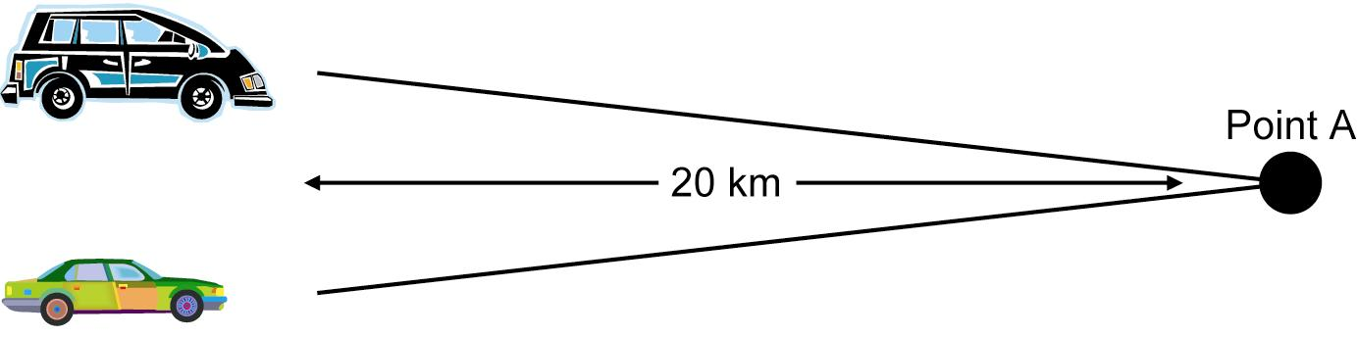

3. Consider this figure. It has a total area of 405 cm².

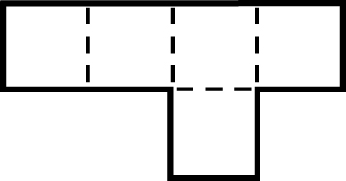
a) What is the area of one square?
b) What is the length of a side of one square?
c) What is the perimeter of the figure?

4. a) Describe the pattern in the chart.
b) Create a set of diagrams that show the pattern.

Figure | 1 | 2 | 3 | 4
Number | 3 | 5 | 7 | 9

5. The following diagram shows a pattern.

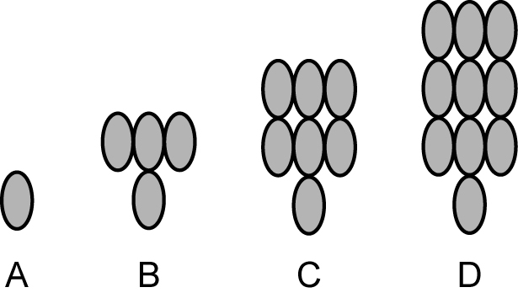
a) Describe the pattern in words.
b) Make a chart that shows the term number
and the increasing number of circles in the
pattern.
c) Draw a graph showing the pattern. Let x
represent the term number and y the number
of circles.

