Chapter 11 Test
For #1 to #6, write EQ beside each item that is an equation or EX beside each item that is an expression.
1. 4x − 9 = 11 ____ 2. 15 + 6x ____ 3. 8c ____
4. −24 = x − 17 ____ 5. ____ 6. 15 + 5x − 9 ____

For #7 and #8, circle the best answer.
7. Which one of the following does the illustration represent?

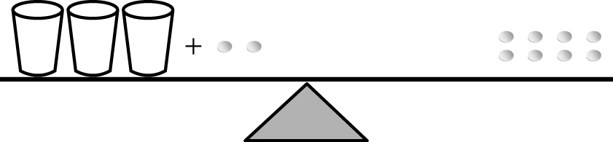

A 3x + 5 = 8 B 3x + 2 + 8
C 3x = 6 D 3x + 2 = 5

8. Which of the following shows the correct set of opposite operations?
A + and – × and ÷ B + and ÷ × and –
C + and × ÷ and – D + and ÷ × and +

Short Answer

For #9 to #16, use a separate sheet of paper.
9. Connie’s age is three more than twice her brother Anthony’s age. If a represents Anthony’s age, write the equation that represents Connie’s age.

10. Mark is checking to see if n = 3 is a solution to the equation 9 = 5n – 6. His work is shown below:

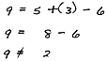

Mark concludes that since the two sides are not equal, 3 is not a solution to the equation. Is Mark correct? Explain why or why not.

11. Solve each equation. Show all of your work.
a) 7m = 42 b) a + 11 = 17
c) d) 19 = x + 6
e) k – 6 = 8 f)

12. Solve each equation and check your answer.
a) 4x + 11 = 27
b) 12 = 7 + 5x
c) 6n + 5 = 47

13. Write an algebraic expression for each word statement.
a) five more than a number
b) three times a number, less eight
c) eight more than two times a number
d) six times a number, less 3

14. Draw a picture to represent 4x – 3 = 5.

Extended Answer

15. Evan is sewing trim on a pair of shorts. He needs four equal length pieces of trim to put two stripes down each side of the shorts. The teacher gives him a piece of black trim that is 185 cm long. He measures and cuts 4 equal lengths. He ends up with a small piece of leftover trim that is 13 cm long. How long is each piece of trim?
a) Write an equation to represent this situation.
b) Solve the equation and check your answer.

16. a) What equation does this balance represent?

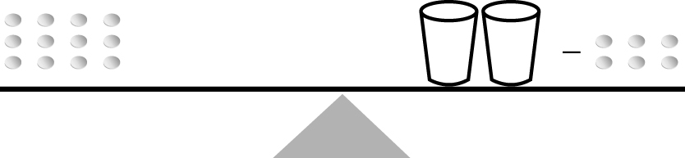

b) Solve the equation. Explain your steps.
c) Draw a diagram to represent the equation 4x + 3 = 15.
d) Solve the equation in part c). Explain your steps.

