Chapter 11 MathLinks 7
Student Resource Answers

11.1 Expressions and Equations, pages 393–394
3. a) expression; x + 6
b) equation; 2x + 2 = 8
c) expression; 4x − 3
d) equation; 3x + 3 = 6
4. a) variable: x; constant: 6
b) numerical coefficient: 2; variable: x;
constant: 2, 8
c) numerical coefficient: 4; variable: x; constant: 3
d) numerical coefficient: 3; variable: x; constant: 3, 6
5. a) x − 8, expression; variable: x,
constant: 8 b) 3x + 2, expression; numerical coefficient: 3, variable: x, constant: 2 c) x − 2 = 8, equation; variable: x, constant: 2, 8
6. a) 2x + 3 = 7, equation; numerical coefficient: 2, variable: x, constant: 3, 7
b) 7 + 2x, expression; numerical coefficient: 2, variable: x, constant: 7
c) 15 = 5 + 2x, equation; numerical coefficient: 2, variable: x, constant: 5, 15
7. a) x + 7, 11; x + 7 = 11
b) 2x − 3, 5; 2x − 3 = 5
c) 6, 1 + 5x; 6 = 1 + 5x
8. a) x − 4, 5; x − 4 = 5
b) 6 + 3x, 9; 6 + 3x = 9
c) 12, 4x − 4; 12 = 4x − 4
9. a) b + 12 b) t − 5 c) a − 52
10. a) 3n − 9 b) c) 8(g − 5) d)
11. a) 2a + 4 = 30 b) c) 4h = 600
12. a) three times a number minus six
b) six times a number plus eight
c) six times the result of a number minus 3
d) nine more than the product of two and a number
13. a) 2x + 2; 3 + x b) 2x + 2 = 3 + x
14. a) 12; 4 + 2m b) Use Guess and Check: Try m = 4; 12 = 4 + 2(4); 12 = 4 + 8; 12 = 12

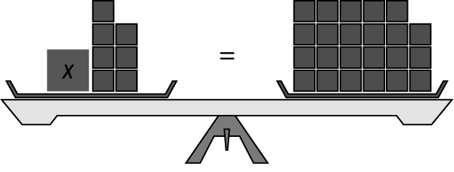
15. a)

b) x + 7 = 23 c) The variable represents the amount of money that Duncan has now. d) $16. Use Guess and Check to find the answer.

11.2 Solve One-Step Equations: x + a = b,
pages 399–401
4. a) z = −3 b) g = 7 c) n = 12 d) k = 3
5. a) b = 3 b) r = 80 c) w = 12 d) h = 2
6. a) 3 b) 8 c) 4
7. a) 3 b) 6 c) 7
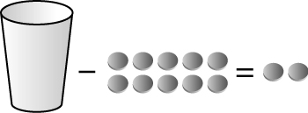  8. a) | b) x − 10 = 2  c) 12
9. a) g = 6 b) w = 0 c) k = 16 d) p = 25
10. a) m = 2 b) k = −5 c) p = 24 d) x = 1
11. a) The money that Charles has in his pocket; this value is unknown. b) $16
12. a) x = 5 is a solution to the equation,
5 + 10 = 15
b) x = 5 is not a solution to the equation, 10 − 5 ≠ 15
c) x = 5 is a solution to the equation,
5 − 7 = −2
d) x = 5 is not a solution to the equation, 42 ≠ 37  5
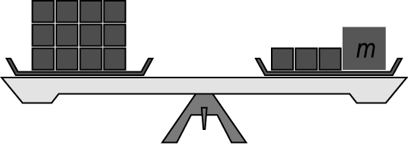  13. a) |  | b) 12  c) m = 9
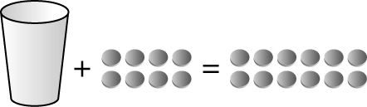  14. a) | b) t + 8 = 12  c) $4
15. a) k − 12 = 48 b) 60 km/h
16. a) c + 15 = 25 b) 10 years
17. a) e − 24 = 86 b) 110 medals
18. 5 binders; 3x + 5 = 20
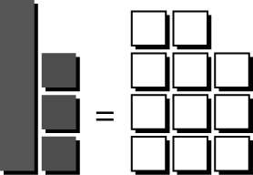  19. a) | b) x + 3 = −11 c) −14  d) Answers may vary. It is difficult to represent negative numbers on a scale.

20. a) No. The sum of his age and years of employment is 73, which is less than 85.
b) 54 years old
21. a) j + 48 = 188 b) 140 decibels
c) When j = 140, w = 14;
14 decibels
22. a) C = 3 + t b) $7 c) 2 h

11.3 Solve One Step Equations: pages 406–407
4. a) 3 b) 5 5. a) x = 16 b) x = 18
6. a) r = 3 b) g = 8 c) d = 3 d) f = 2
7. a) p = 21 b) v = 25 c) c = 36 d) x = 28
8. a) 6 b) 3 c) 11 d) 9
9. a) r = 9 b) j = 25 c) g = 12 d) t = 3
10. 7 h 11. a) 6 b) 4 c) 11 d) 4
12. a) u = 44 b) c = 156
c) w = 108 d) x = 0
13. 36 h
14. a) Yes, 8 × 3 = 24 b) Yes, 10 × 3 = 30
c) No, 7 × 3 ≠ 35 d) No, 48 ≠ 12 × 3
15. a) Yes, 1 = 8 ÷ 8 b) No, 8 ÷ 4 ≠ 16
c) Yes, 4 = 8 ÷ 2 d) No, 8 ÷ 2 ≠ 16
16. a) 300t = 6000 b) 20 min
17. a) b) 42 years old
18. $165 19. 7 cm
20. a) w + w + 2w + 2w = 240 b) 6w = 240
c) w = 40 m; l = 80 m
21. 5 pencils each

11.4 Solve Two-Step Equations:
ax + b = c, pages 411–413
4. a) x = 8 b) n = 3 5. a) n = 4 b) n = 5
6. a) x = 1 b) x = 3
7. a) s = 2 b) k = 3 c) n = 2 d) w = 4
8. $4
9. a) Add 2. b) Subtract 3.
c) Subtract 10. d) Add 5.
10. a) Divide by 6. b) Divide by 3.
c) Divide by 2. d) Divide by 9.
11. a) r = 2 b) m = 1 c) g = 2 d) f = 7
12. a) k = 4 b) x = 3 c) n = 2 d) n = 4
13. 15 DVDs
14. a) No, 8(6) + 8 ≠ 25
b) Yes, 3 + 7(6) = 45
c) No, 58 ≠ 10(6) − 1
d) No, 48 ≠ 3(6) + 12
15. a) r = 9 b) y = 20 c) g = 9 d) p = 6
16. a) C is the cost for one day at camp; s is number of students. b) 20 students
17. a) 54 = 2p + 6 b) $24 18. 6
19. Answers will vary. For example:
a) 2x + 4 = 16 b) x = 6
c) x = 4
d) No. Following a different order of operations resulted in a different answer.
e) Substitute the value for the variable into the original equation and see if the left side equals the right side.
20. 23°C 21. a) 25 m/s b) 3 s

Chapter 11 Review, pages 414–415
1. add; multiply 2. equation
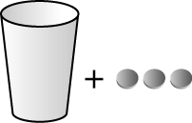
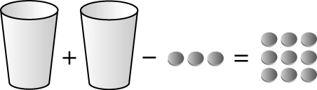
3. a) b)

4. a) variable: x; constant: 3 b) variable: r; numerical coefficient: 2; constant: 3, 9
5. a) x + 4, 6; x + 4 = 6
b) 2x − 3, 9; 2x − 3 = 9
6. a) 3k − 1 = 22 b)
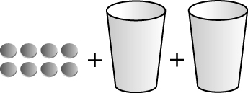
7. a) b) 14

8. a) 5 counters b) 7 counters 9. x = 8
10. a) w = 2 b) f = 9 c) g = 20 d) b = 6
11. a) t = 28 b) y = 0 c) x = 5 d) p = 17
12. a) x + 10 = 24 b) 14 medals
13. 6 14. h = 12
15. a) b) x = 10
16. a) r = 6 b) p = 32 c) w = 7 d) c = 66
17. a) Divide by 3; x = 4 b) Divide by 4; n = 4

18. a) Multiply by 5; v = 35
b) Multiply by 11; t = 132
19. a) b) 63 years old
20. a) x = 6 b) x = 9
21. a) g = 12 b) x = 30 c) h = 7 d) p = 7
22. 27 baseball cards; 2b + 21 = 75

Chapter 11 Practice Test, pages 416–417
1. C 2. B 3. D 4. D 5. A
6. a) Add 4.
b) Divide both sides of the equation by 2.
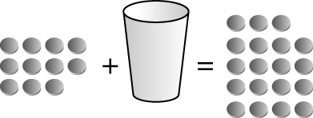
7. a) b) 8

8. a) b = 5 b) x = 16 c) x = 18 d) h = 38
9. x = 24 10. x = 4 11. 14
12. a) C represents the cost for one day of the hiking trip; p represents the number of people on the hiking trip b) $800
c) C = 800d; C is the cost of the hiking trip and d is the number of days for the hiking trip
d) 3200 = 800d; 4 days

13. a) 2x + 3 = 11
b) x = 4; Subtract 3 from each side. Divide each side by 2.
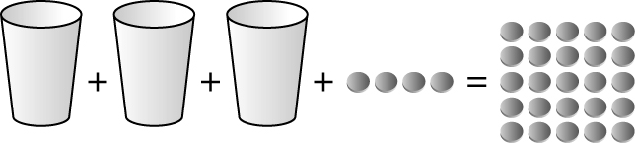
c)

d) x = 7; Subtract 4 from each side. Divide each side by 3.
14. a) 5r + 20 = 245 b) r = 45 cm

