Chapter 12 Self-Assessment
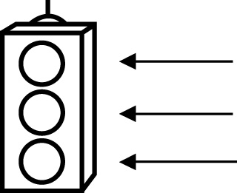 | RED I have not started moving in this area.  YELLOW I am moving along with caution in this area.  GREEN I am moving along confidently in this area.

BEFORE | DURING  (What I can do if I mark yellow or red.) | AFTER  (Proof that I can do this.)
12.1

I can find the median of a set of data.
I can find the mode of a set of data.
12.2
I can find the mean for a set of data.
I can solve problems by finding the mean.
12.3
I can find the range for a set of data.
I can find outliers in sets of data.

12.4
I can explain the effects of outliers on measures of central
tendency.
I can justify whether outliers should be included when
finding measures of
central tendency.
I can give examples of when outliers should be included
when finding
measures of central
tendency.
12.5
I can decide when it is best to use the mean, median, or
mode to describe a
set of data.
I can give examples of when it is best
to use the mean,
median, or mode to
describe a set of data.
I can solve problems using mean, median, and mode.

