Working With Data
1. List all the four-digit numbers that are even, have a 6 in the tens place, and whose digits add to 12.

2. Is 349 × 0.9 greater than, less than, or equal to 349? How do you know?
______________________________________________________________
______________________________________________________________

3. Suppose you know that 48 ÷ 16 = 3. Without finding the exact answer, tell whether the answer to 48 ÷ 15.99 is greater than, less than, or equal to 3. Why?
______________________________________________________________
______________________________________________________________

4. Use the multiplication below to answer the questions that follow.

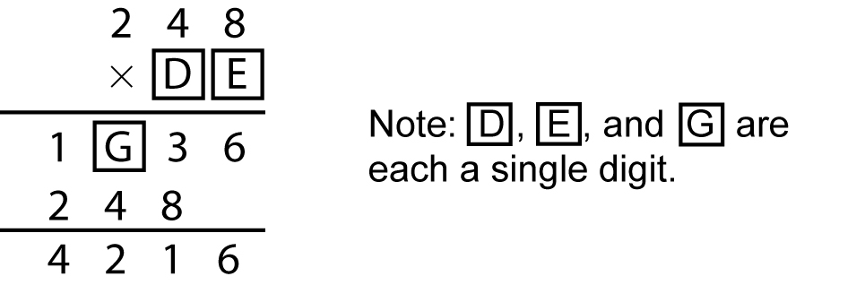

a) Can E be 2? Explain.
___________________________________________________________
___________________________________________________________
b) What is the value of D? Why?
___________________________________________________________
___________________________________________________________
c) What is the value of G? How do you know?
___________________________________________________________
___________________________________________________________

5. The number 15 can be written as the sum of consecutive numbers in several ways. Some of these are
7 + 8
4 + 5 + 6
1 + 2 + 3 + 4 + 5
0 + 1 + 2 + 3 + 4 + 5
Show how to express each of the whole numbers from 20 to 25 as the sum
of consecutive integers.
______________________________________________________________
______________________________________________________________
______________________________________________________________
______________________________________________________________
______________________________________________________________

6. Five different whole numbers are listed from smallest to largest. The sum of the largest and smallest numbers is 14. The total for all five numbers is 38.
If the smallest and largest numbers are odd and all the other numbers are even, what are the numbers? Give at least two different answers.

7. Some students were asked for their favourite music type. The results of the survey are shown in the frequency table.
Favourite Music | Tally | Frequency
Rap | 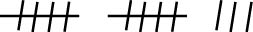 | 13
Alternative & Punk | 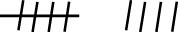
Rock | 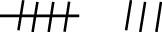
Jazz | 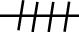
Western
a) Complete the frequency table.
b) Assume that each student chose one music type. How many students participated in the survey? ______
c) Which music type was most popular? ___________________
How many students picked this music type? ______
d) Which music type was least popular? ____________________
What is the frequency of this music type? ______
e) How many more students chose Rap than Rock? ______
- How many fewer students chose Jazz than Alternative & Punk? ______

