Section 12.2 Extra Practice
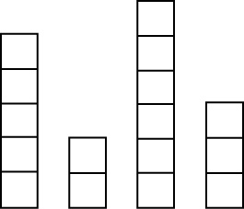
1. The set of boxes represents four towers. They are of different heights because they are each made up of a different number of blocks.
a) Make actual towers using centimetre linking
cubes.
b) Move cubes from the taller towers to the shorter
ones until all towers are the same size.
c) Draw your new towers.

d) What is the mean tower height? ______

2. a) On a test out of 10, six students had scores of 10, 3, 9, 6, 6, and 8.
Find the mean of their test scores.
10 + 3 + 9 + 6 + 6 + 8 = _____
______ ÷ 6 = _____
b) Fill in the blanks to explain how to find the mean.
To find the mean, we ___________________ the scores, then divide by
the ___________________ of scores.

3. Find the mean of each of the following sets of data.

Data Set | Sum | Calculation of Mean | Mean
a) 12, 4, 8, 11, 7, 3, 11 |  | ______ ÷ 7 = ______
b) 15, 11, 6, 17, 8, 10, 4, 14, 9, 18, 20
c) 13, 21, 28, 41, 16,
11, 31
d) 3800, 2700, 1650, 1122, 1360, 4500
e) 100 000, 60 000,
40 000, 30 000
f) 17, 28, 19, 21, 14,
26, 25, 14, 20, 14, 22
g) 44, 35, 47, 40, 37,
43, 40, 37, 42, 37, 49

