Section 12.4 Math Link
This worksheet will help you with the Math Link on page 445.

In a gymnastics competition, each performance was judged by eight judges on
a scale from 0.25 to 10.00. In order to calculate each gymnast’s overall performance, the top score and bottom score were removed and the mean of the remaining scores was determined. This value is called the trimmed mean.

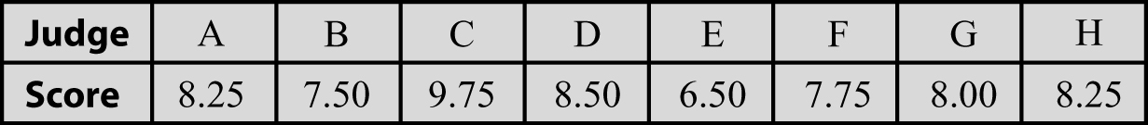
Jordan recorded the following scores for her friend’s performance.

Round your answers to 2 decimal places.

1. List the scores from the lowest to the highest:
_____ _____ _____ _____ _____ _____ _____ _____

2. Using all the scores, what is the median? ______

3. Using all the scores, what is the mean? _____________________________

4. a) Using all the scores, what is the highest score? ______
b) Using all the scores, what is the lowest score? ______
c) Using all the scores, what is the range? ______ – ______ = ______

5. Remove the top and bottom scores.
Show the new list: _____ _____ _____ _____ _____ _____

6. What is the new median? ______

7. What is the new mean? _________________________________________

8. What is the new range? ______ – ______ = ______

9. After you removed the top and bottom scores, which changed the most: the median, mean, or range? ____________________

10. Would you consider the highest and lowest scores to be outliers in this example? YES NO
Explain. _____________________________________________________
____________________________________________________________

