Chapter 2 Self-Assessment
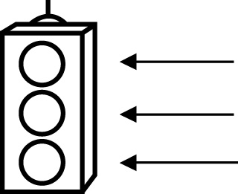 | RED I have not started moving in this area.  YELLOW I am moving along with caution in this area.  GREEN I am moving along confidently in this area.

BEFORE | DURING  (What I can do if I mark yellow or red.) | AFTER  (Proof that I can do this.)
2.1

I can use estimation to check if sums are reasonable.
I can use front-end estimation to place the decimal in a
sum.
I can use estimation to check if differences are
reasonable.
I can use front-end estimation to place the decimal in a
difference.
I can solve problems using addition of decimal numbers.
I can solve problems using subtraction of decimal numbers.
2.2
I can use estimation to place a decimal point in a product.
I can multiply decimal numbers with a calculator.
I can multiply decimal numbers without a calculator.
I can solve problems using estimation and multiplication of
decimal numbers.
2.3
I can use estimation to place a decimal point in a quotient.
I can divide decimal numbers with a calculator.
I can divide decimal numbers without a calculator.
I can solve problems using estimation and division of decimal
numbers.
2.4
I can use the order of operations with decimal numbers.
I can solve problems using operations on decimals to the
thousandth's place.

