Chapter 2 BLM Answers

BLM 2–2 Operations on Decimal Numbers
1. Greater than 3. There are 3 groups of 16 in 48. 15 < 16, so there will be slightly more groups (or greater than) of 15 in 48.
2. a) subtract 50 or add 50
b) subtract 0.9 or add 0.1
c) subtract 800 or add 200
d) subtract 0.8 or add 0.2
3. a) 10.606666 b) 11.57619
c) 200.3620 d) 9.086206
4.

Find 100, which is halfway between 0 and 200. Find 50, which is halfway between 0 and 100. Label 60, which is slightly greater than 50.
5. a) = b) < c) < d) >

BLM 2–4 Section 2.1 Extra Practice
1. a) 40 + 30 + 90 = 160
b) 40 + 10 + 10 = 60
2. a) $400 – $200 = $200; lower
b) 6000 – 3000 = 3000; lower
3. a) 50 + 30 + 90 = 170
b) 50 + 10 + 20 = 80
c) $500 – $200 = $300
d) 7000 – 3000 = 4000
4. a) 6.300 b) 4.315
7.000 6.040
+ 8.692 + 9.100
21.992 19.455
c) 0.60 d) 6.90
– 0.47 – 0.82
0.13 6.08

BLM 2–6 Section 2.2 Extra Practice
1. a) 50 × 2 = 100; 148.50
b) 3 × 5 = 15; 17.28
c) 30 × 2 = 60; 94.64
d) 3 × 6 = 18; 23.498
e) 20 × 0.3 = 6; 6.78
f) 70 × 0.8 = 56; 59.36
2. Estimates may vary.
a) 10.4 b) 187.8 c) 38.92 d) 56.2
3. a) 6 × 3 = 18; 20.8
b) 10 × 7 =70; 96.75
c) 300 × 6 = 1800; 2110.5
d) 70 × 5 = 350; 392.08
e) 10 × 0.3 = 3; 3.993
f) 7 × 0.4 = 2.8; 3.7728
4. Estimates may vary. For example:
50 × 2 = 100. Lesley’s mass is 79.5 kg.

BLM 2–8 Section 2.3 Extra Practice
1. a) 8
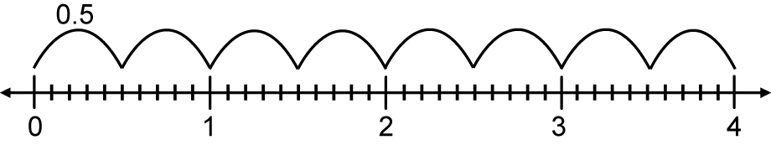
b) 5
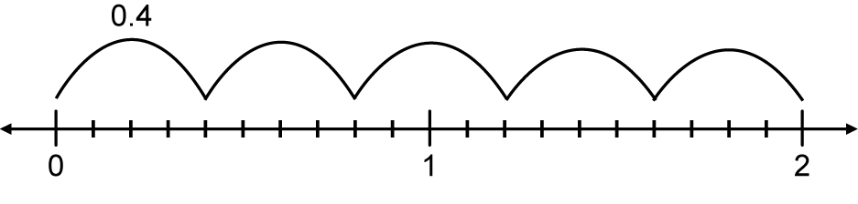
2. a) 2 b) 15
3. a) 3.328 b) 26.25
4. a) 4.5 b) 3.7
5. $6.50

BLM 2–10 Section 2.4 Extra Practice
1. a) 1 b) 3 c) 23 d) 4 e) 5.6 f) 6.7
2. a) (7 + 5) × 0.3 = 3.6
b) 1.2 ÷ (9 – 3) = 0.2
c) 5 + 7.2 ÷ 0.9 = 13
d) (10 – 4) × 0.5 – 1 = 2
e) 1.1 + 0.4 ÷ 8 + 3 = 4.15
3. a) 5.2 b) (5 + 0.4) ÷ 2 = 2.7
4. a) 13 b) 165 c) 3.5
5. 2 × 18.40 + 3 × 35.50 = $143.30

BLM 2–11 Chapter 2 Test
1. B 2. A 3. D 4. C 5. D 6. D 7. A 8. A
9. B 10. 1.14 11. (12 – 7)
12. a) 1.407 b) 10.59
c) 19.7952 d) 1.7520
13. a) 174.75 b) 2.525
14. a) (5.4 – 4) × 0.12 = 0.168
b) (7.1 + 6.8) × 3 ÷ 0.4 = 104.25
c) 6.7 ÷ (0.3 + 5.2) × 3.9 = 4.75
d) (9.3 – 5.5) × (2.7 + 0.6) = 12.54
15. $408.75
16. 100 × $0.12 + 100 × 8 × $0.15 = $132
17. a) 29.93
b) Terry’s estimate is more accurate. Jana
divided by the number of items when
she should have multiplied.
c) $168.50 d) underestimate

