Chapter 3 Self-Assessment
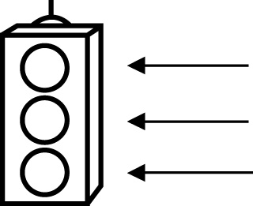 | RED I have not started moving in this area.  YELLOW I am moving along with caution in this area.  GREEN I am moving along confidently in this area.

BEFORE | DURING  (What I can do if I mark yellow or red.) | AFTER  (Proof that I can do this.)
3.1

I can identify line segments that are parallel to each other.
I can draw line segments that are parallel to each
other.
I can identify line segments that are at right angles to each
other.
I can draw line segments that are at right angles to each other.
I can describe
real-life examples of parallel line segments
and perpendicular line
segments.
3.2
I can draw a line
that divides a line segment in half and is at right angles to it.

3.3
I can draw a line that divides an angle in half.
3.4
I can show how the area of a rectangle can be used to find
the area of a
parallelogram.
I can develop the formula for the area of a parallelogram.
I can solve problems to do with the area
of a parallelogram.
3.5
I can show how the area of a rectangle can be used to find
the area of a triangle.
I can develop the formula for the area of a triangle.
I can solve problems to do with the area
of a triangle.

