Geometry and Measurement
1. Predict which angle has a measure of about 75°. Check your prediction by measuring the angle.
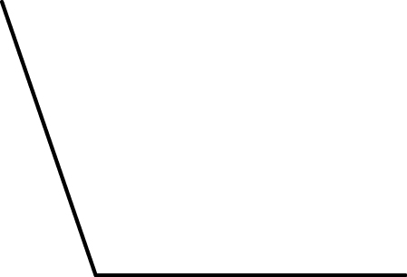  a) |   b) | 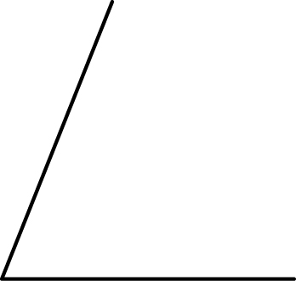  c) | 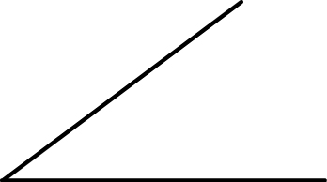  d)

2. In each diagram, all angles are right angles. Find the missing lengths for
P and Q.
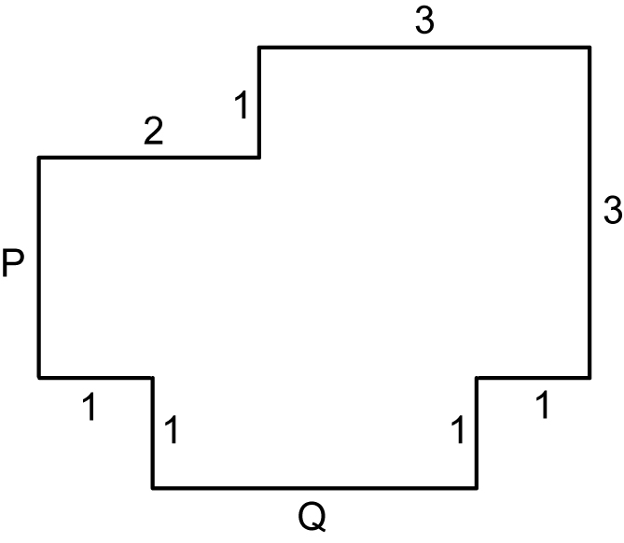  a) | 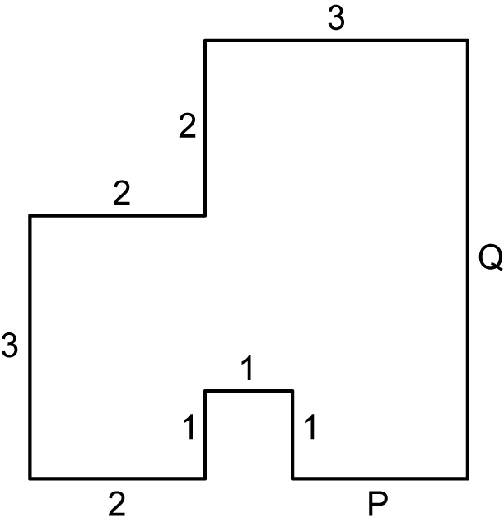  b)

3. Find the area for each shape by counting all the unit squares and half squares.
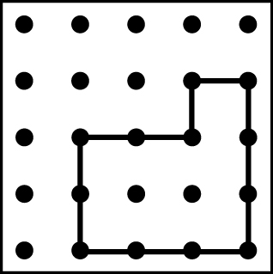  a) | 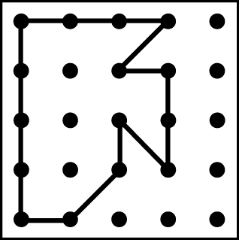  b) | 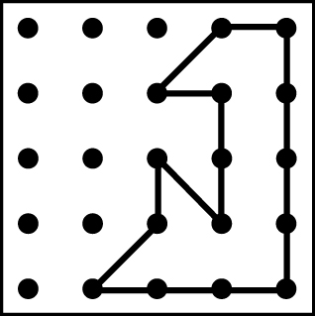  c)

4. Measure to find the area of the following shapes. Give your answers in
square centimetres.
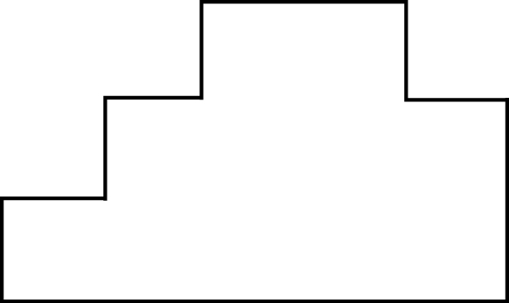  a) | 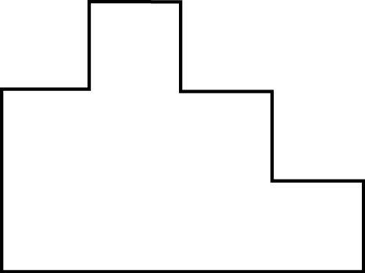  b)

