Section 3.1 Extra Practice
For #1 to #5, write the letter for the term that best matches each diagram.

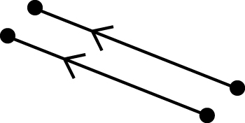  1.  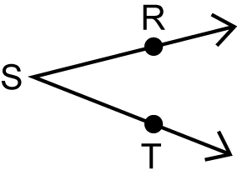  2.  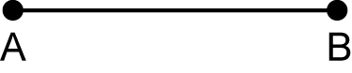  3.    4.  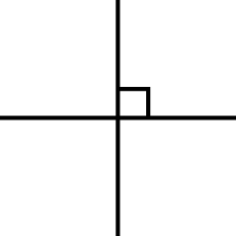  5. | A vertex  B parallel line segments  C RST  D perpendicular lines  E line segment

6. Label the pairs of lines segments as
- parallel or
- perpendicular or
- neither
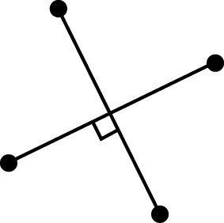  a) | 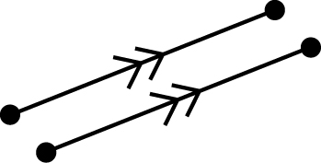  b) | 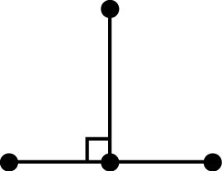  c)
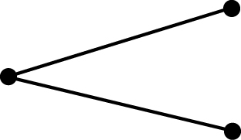  d) |   e) | 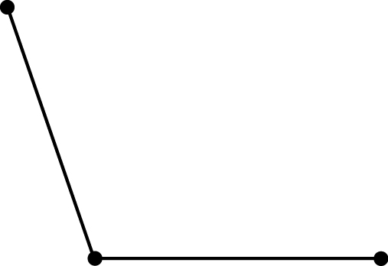  f)

