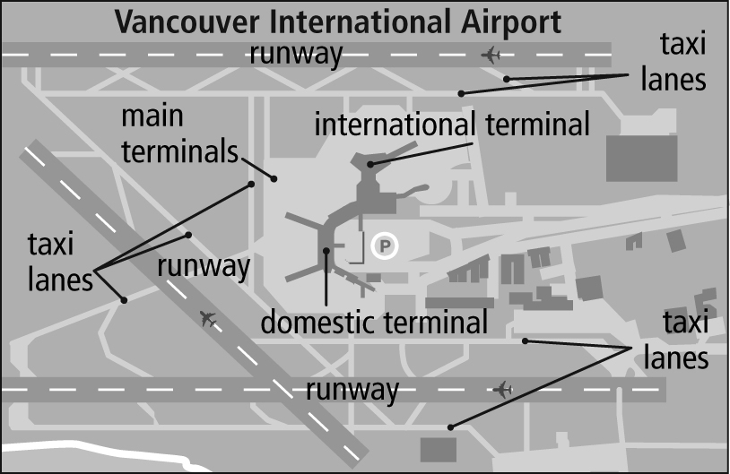
Section 3.1 Math Link
This worksheet will help you with the Math Link on page 88.

You are going to create an airport design. Look at the diagram of the Vancouver International Airport on page 88 for ideas. You will add to your design throughout Chapter 3.

1. On a large piece of paper (11 × 17 or larger), draw a border around the outside edge of the paper.

2. a) Write at the bottom of the paper that 1 cm represents 100 m.
b) Use the following pattern to help you calculate the length of the runways on your design.
1 cm = 100 m
2 cm = 200 m
3 cm = 300 m
4 cm = 400 m
5 cm = 500 m

If you want to show a runway 1000 m long, how many centimetres long should you make it in your design? Continue the pattern to find out. _______________

3. Draw four runways and/or taxi lanes using the following guidelines. Place a checkmark in the last column to show that you have met each guideline.

Guidelines | Completed
a) The runways must be parallel or perpendicular to each other.
b) The runways are 1200 m to 1500 m long (12 cm to 15 cm on your design), and 30 m to 60 m wide (0.3 to 0.6 cm on your design).
c) Taxi lanes connect the runways. Taxi lanes are 20 m to
30 m wide (0.2 cm to 0.3 cm on your design). They can be any length that works with your design.
d) Draw the runways and taxi lanes so that 1 cm represents 100 m.

