Section 3.3 Extra Practice
1. Fill in the blanks to complete these sentences. The first letter of each missing word has been provided.
An a____________ b___________ divides an angle into two e___________ parts.
An angle that is less than 90° is called an a____________ angle.
An angle that is 90° is called a r____________ angle.
An angle that is greater than 90° and less than 180° is called an o____________ angle.

2. In each blank, write whether the angle is an acute, obtuse, or right angle.

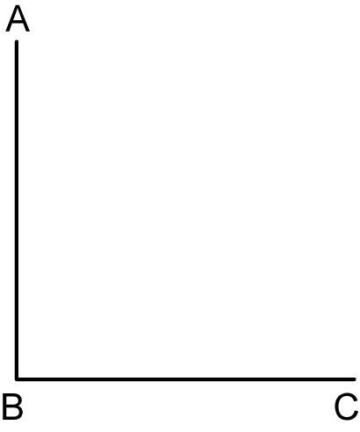  a)  _____________ | 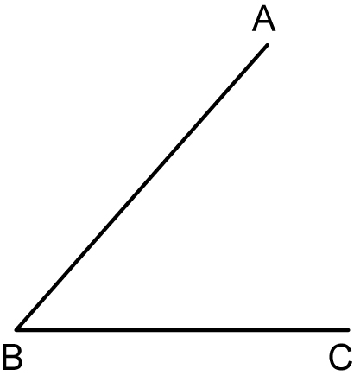  b)  ____________ | 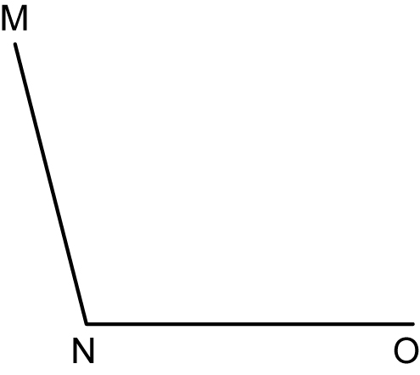  c)  ____________

3. Measure each angle. Write the measure in the blank. Then use a protractor, ruler, and pencil to bisect the angles.

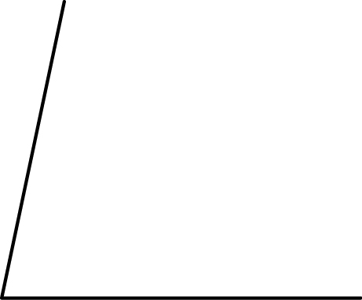  a)  ______ | 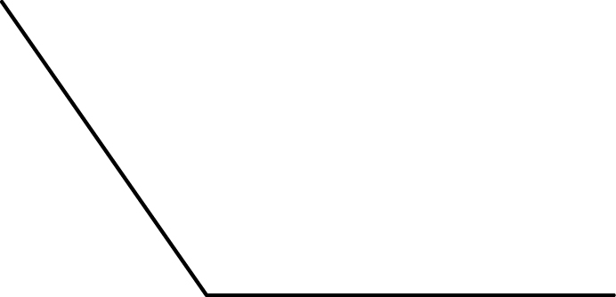  b)  ______

