Section 3.3 Math Link
This worksheet will help you with the Math Link on page 99.

Study the diagram of the Calgary International Airport.

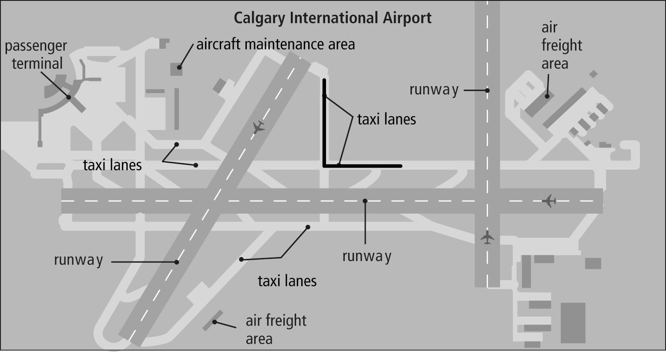

1. a) Look at the two taxi lanes marked in black. What is the measure of the angle made by these two taxi lanes? ____
b) Draw a line that is the angle bisector of this angle.
c) Explain how you know that the line you drew is an angle bisector.
___________________________________________________________
___________________________________________________________
___________________________________________________________
___________________________________________________________

2. Add a runway or taxi lane to your own airport design that bisects the angle made by two others.

3. Explain why you chose that location for your runway or taxi lane.
_____________________________________________________________
_____________________________________________________________
_____________________________________________________________
_____________________________________________________________

