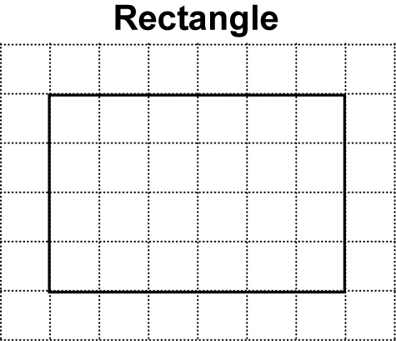
Section 3.4 Extra Practice
1. Fill in the blanks.
a) How many squares are there inside the rectangle?
____________________
b) Instead of counting each square, you
can multiply the ____________________ by
the ____________________.
- Area of a rectangle = _______________ × _______________
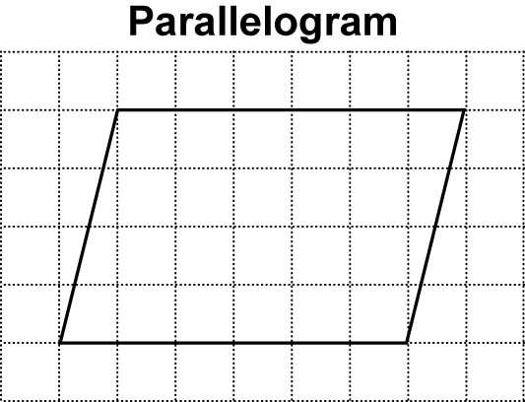
or A = ___ × ___.

d) The length of the rectangle is the same as the
____________________ of the parallelogram.
e) The width of the rectangle is the same as the
____________________ of the parallelogram.
f) Area of a parallelogram = _______________ × _______________
or A = ___ × ___

2. Use your knowledge of the area of a parallelogram to fill in the blanks in the table below.

Base | Height | Area of Parallelogram
a) 5 cm | 3 cm | A = b × h  A = 5 × 3  A = _____ cm²
b) 6 cm | 4 cm | A = ____ × ____  A =___________
c) I know the area. I can find the base: | 5 cm | 45 cm²
d) 12 cm | I know the area. I can find the height: | 120 cm²

