Chapter 3 Test
For #1 to #5, choose the letter representing the term that best matches each illustration. Each letter may be used once or not at all.

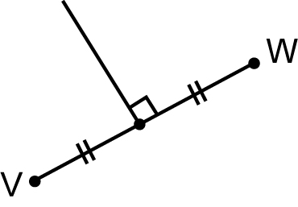  1. |  | 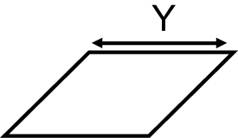  2. |  | A parallel  B perpendicular  C area  D height  E angle bisector  F base  G vertex  H perpendicular bisector
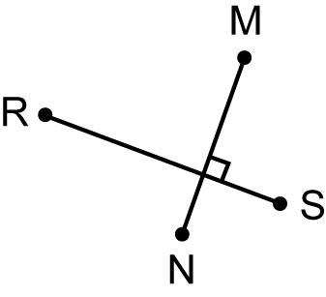  3. | 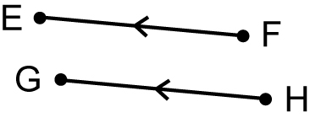  4. |  | 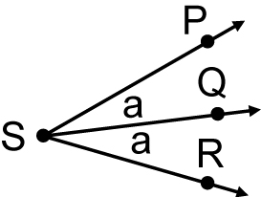  5.

6. The edges of the paper that meet in the corner of your test paper are best described as being:
A acute B obtuse C parallel D perpendicular

7. What is the relationship between line segments AB and RS?

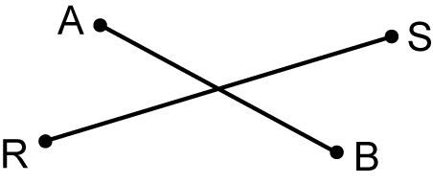

A parallel B perpendicular C intersecting D base

8. Chan took a piece of paper and carefully folded it twice as shown below. When he unfolds the paper, how would the fold lines appear on the paper?

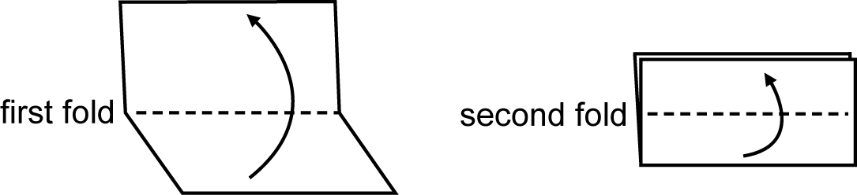

A parallel B perpendicular C bisecting D obtuse

Short Answer
9. a) Construct an angle of 36° and label it PQR.
b) Draw an angle bisector and label it QT.

- Calculate the area of the figure shown below.

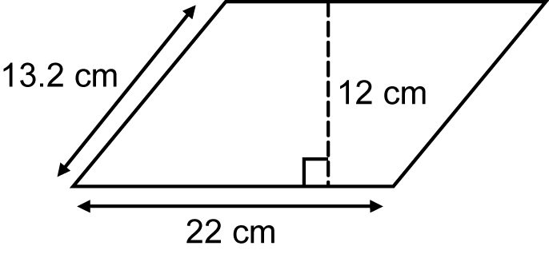

11. Copy line segment JK.

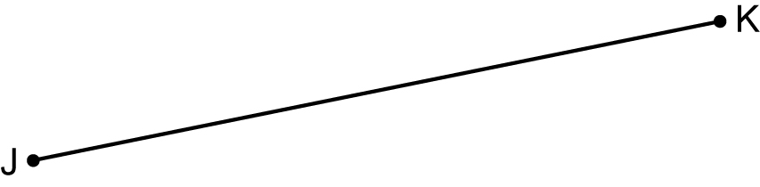

a) Draw a perpendicular bisector that passes through JK at point M and
label it.
b) Draw a line segment PT so that it is parallel to JK and label it.

Extended Answer
12. A sandbox is a parallelogram with a height of 4 m and a base of 5 m. You need to make a lid for the sandbox.
a) What area do you need to cover?
b) If material for the cover costs $12 per square metre, how much will it
cost to cover the sandbox?

13. Jared’s apartment has a living room in the shape of a rectangle. He wants to install some flooring in a triangular shape as shown. Point A bisects side PS.
a) What is the area of the triangular surface?
b) If the floor tile costs $12.50 per square metre, what is the total cost before tax?

