Chapter 3 BLM Answers

BLM 3–2 Geometry and Measurement
1. c)
2. a) P = 2; Q = 3 b) P = 2; Q = 5
3. a) 7 units² b) 9.5 units² c) 6.5 units²
4. Answers may vary. For example:
a) 7.7 cm² b) 4.9 cm²

BLM 3–3 Section 3.1 Extra Practice
1. B 2. C 3. E 4. A 5. D
6. a) perpendicular b) parallel
c) perpendicular d) neither
e) parallel f) neither

BLM 3–5 Section 3.2 Extra Practice
1. perpendicular bisector; line; line; two; perpendicular; line
2. a) No. The line is not perpendicular.
b) No. The perpendicular line does not
divide the line segment into two equal
parts.
c) Yes d) No e) No

BLM 3–7 Section 3.3 Extra Practice
1. angle bisector; equal; acute; right; obtuse
2. a) right angle b) acute angle c) obtuse
3. a) 78° b) 125°
Ensure student draws bisectors accurately.

BLM 3–9 Section 3.4 Extra Practice
1. a) 24 b) width, length; or length, width
c) Area of a rectangle = width × length or
A = w × l; or Area of a rectangle
= length × width or A = l × w
d) base e) height
f) Area of a parallelogram = base × height
or A = b × h; or Area of a parallelogram
= height × base or A = h × b
2. a) 15 cm² b) 24 cm²
c) Answers may vary. For example: using
Guess and Check; 9 cm
d) Answers may vary. For example: using
Guess and Check; 10 cm

BLM 3–11 Section 3.5 Extra Practice
1. a) Area of a parallelogram = base × height
or A = b × h; or Area of a parallelogram
= height × base or A = h × b
b) parallelogram; half; parallelogram
c) Area of a triangle = base × height ÷ 2
or A = b × h ÷ 2; or Area of a triangle
= height × base ÷ 2 or A = h × b ÷ 2
2. a) 9 cm² b) 6 cm² c) 45 cm² d) 17.5 cm²

BLM 3–13 Chapter 3 Test
1. H 2. F 3. B 4. A 5. E 6. D 7. C 8. A
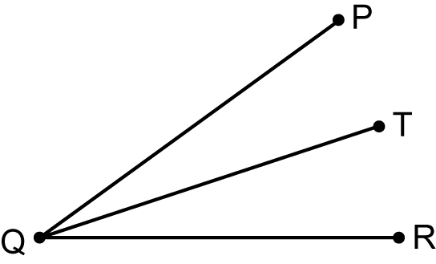
9. a), b)

10. 264 cm²
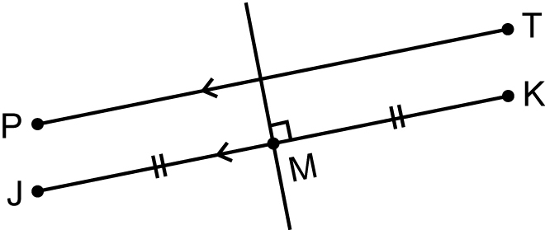
11. a), b)

12. a) 20 m² b) 12 × 20 = $240
13. a) 0.845 m² b) $10.56

