Chapter 6 Self-Assessment
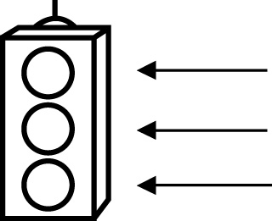 | RED I have not started moving in this area.  YELLOW I am moving along with caution in this area.  GREEN I am moving along confidently in this area.

BEFORE | DURING  (What I can do if I mark yellow or red.) | AFTER  (Proof that I can do this.)
6.1

I can tell if a number can be divided evenly by 2, 5, and 10.
I can tell if a number can be divided evenly by 4 and 8.
I can tell if a number can be divided evenly by 3, 6, and 9.
I can show why a
number cannot be divided by 0.
I can sort a set of
numbers using
divisibility rules.
I can find the factors of a number using divisibility rules.
I can write a fraction in lowest terms using common factors.

6.2
I can add fractions with like denominators using models and
diagrams.
I can add fractions with like denominators using addition
statements.
I can solve a problem to do with the addition of fractions.
I can check my solution to a fraction addition problem.
6.3
I can subtract fractions with like denominators using models and
diagrams.
I can subtract fractions with like denominators using
addition statements.
I can solve a problem to do with the subtraction of fractions.
I can check my solution to a fraction subtraction problem.

