Introduction to Fraction Operations
1. Select one of the following fractions.

Place your fraction in the centre of a piece of paper as shown. Represent the fraction using words, symbols, operations, and diagrams.
Show the fraction in at least six different ways.

2. What part of each rectangle is shaded? Give your answer as a fraction,
a decimal, and a percent.
a) b)
3
4
5
2
3. Suppose you have the following number cards:

Use two cards to make a fraction of the form that is

a) equal to b) between and 1
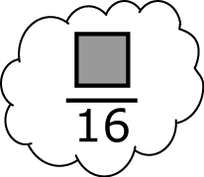

4. Consider fractions with a denominator of 16.

Choose a whole number numerator that would make the fraction
a) a little less than b) a little more than c) almost 1

5. Arrange the following fractions from smallest to largest: , , .

6. Which is larger: or ? Explain why in two different ways.

7. Arrange the following fractions in order from greatest to least.
a) , , b) , , ,

