Section 6.1 Math Link
This worksheet will help you with the Math Link on page 209.

The diagram on page 209 shows the fraction of time Joseph spends on all his activities during a 24-h day. Use it to answer the questions below.

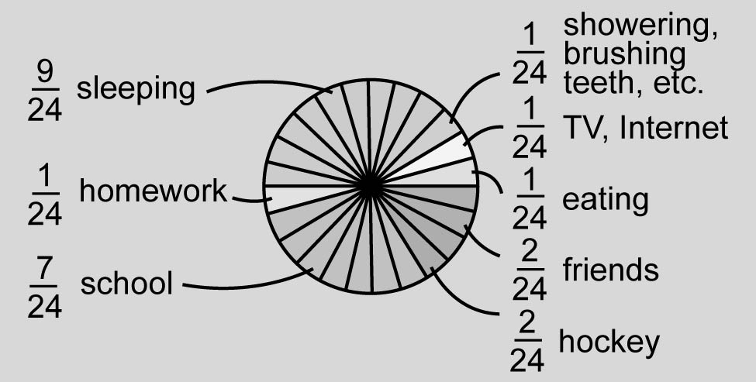

1. Use the divisibility rules to find the factors of 24. List them below.

2. Use the factors of 24 to determine which fractions in the diagram are in lowest terms. List these fractions.

3. Which fractions in the diagram are not in lowest terms? List these fractions.

4. Use the factors of 24 to rewrite each fraction in #3 in lowest terms.

5. Does your understanding of the diagram change now that you have written the fractions in lowest terms? YES NO Explain.
______________________________________________________________

