Chapter 6 Test
For #1 to #6, choose a term from the list on the right that best matches each description on the left. Each letter may be used more than once or not at all.

1. _____ The part of the fraction that tells how many parts out of the whole you have  2. _____ When a number can be divided by another number, with no remainder  3. _____ A number that will divide into another number, with no remainder  4. _____ The part of the fraction that tells into how many parts the whole has been cut  5. _____ 12 ÷ 0  6. _____ | A numerator  B not possible  C factor  D divisible  E denominator  F written in lowest terms  G multiple

For #7 to #10, circle the best answer.

7. Adding all of the digits in a whole number and then checking if the sum is divisible by 9 is the rule for
A divisibility by 9 B divisibility by 6
C divisibility by 4 D divisibility by 3

8. ABCDE represents a five-digit whole number. You are told that ABCDE is divisible by 5. Which of the following must be true?
A E must be 0, 2, 4, 6, or 8. B E must be 0, 2, 4, or 6.
C E must be 0. D E must be 0 or 5.

9. 32 81 is a five-digit whole number. You are told that 32 81 is divisible by 3. Which one of the following could be true?
A = 2 B = 3 C = 4 D = 5

Short Answer

10. Add or subtract. Write your answers in lowest terms.
a) = ______________ b) = _______________
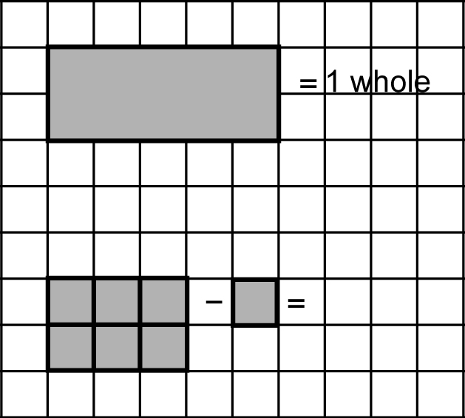
11. In the illustration, the large rectangle is one whole. How much of the whole is made when the pieces are subtracted as shown? Write your answer in lowest terms.
__________________________

12. A large number of people were at an international meeting. Out of all the people, were from Canada, were from the United States, from China, from Korea, and the rest were from different countries in Europe. What fraction of the people were from Europe? Show your work.

Extended Response
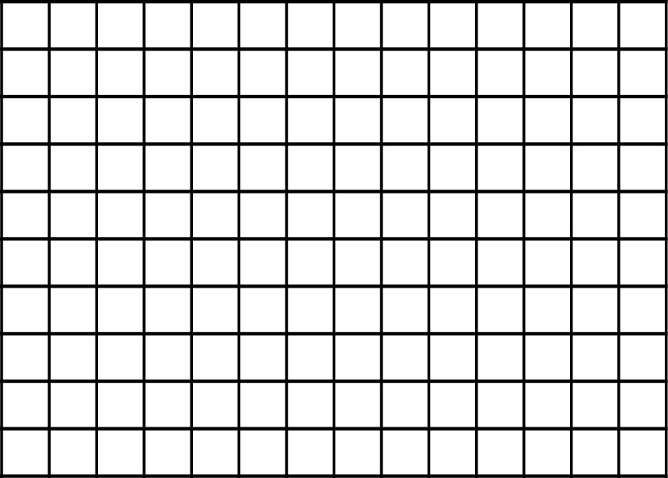
13. a) Make a diagram on the grid that shows how to add the following:
In your diagram, show
as well as the final answer.
b) Write the final answer in fraction
form. ______

14. Write a problem to do with a real-life situation that involves the subtraction of fractions. Include the solution to your problem.
_____________________________________________________________
_____________________________________________________________
_____________________________________________________________

