Chapter 6 MathLinks 7
Student Resource Answers

6.1 Divisibility, pages 207–209
5. 1010, 605, 900, 325. The last digit of each number is 0 or 5.
6. 124, 3048, 1432. The number formed by the last two digits of each number is divisible by 2 at least twice.
7. a) 330 is divisible by neither 4 nor 8.  b) The number is divisible by 2 because 2 is a factor of 4 and a factor of 8. | 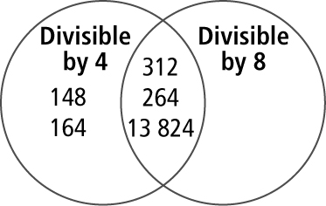

8. a) |  | Divisible by 6 | Not Divisible by 6
 | Divisible by 10 | 35 010  9810 | 31 990
 | Not Divisible by 10 | 5832 | 243
b) The number is divisible by 2 because 2 is a factor of 6 and a factor of 10.
9. a) 1, 2, 3, 4, 6, 9, 12, 18, 36
b) 1, 3, 5, 15 c) 1, 2, 4, 7, 14, 28
10. a) 1, 2, 3, 6, 9, 18
b) 1, 2, 3, 6, 9, 18, 27, 54
c) 1, 2, 3, 4, 6, 8, 9, 12, 18, 24, 36, 72
11. a) 1, 3 b) 1, 2, 4 c) 1, 2, 3, 6
12. a) 1, 5 b) 1, 2, 4 c) 1, 3
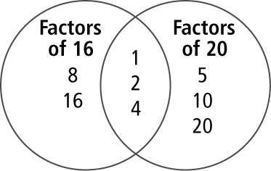
13. a) b) 4

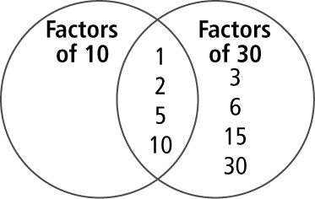
14. a) b) 10

15. a) b) c) d) e) f)
16. a) b) c) d) e) f)
17. a) A, B, C, D b) A, B, E
c) Answers may vary. Choose the flowers that can be divided into both groups of
2 and groups of 3 because 2 and 3 are factors of 6.
18. Answers may vary.
a) 12 345 b) 1 234 698
19. a) No b) Yes c) No
20. Yes. Answers may vary. 2 and 3 are factors of 6; 2 and 5 are factors of 10;
3 and 5 are factors of 15.
21. Answers may vary. A number is divisible by 9 if the sum of the digits is divisible by 3 twice.
22. a) 9 students b) 6 komatiks
23. No. Answers may vary. It is not possible to divide 12 peaches into 0 groups.
24. 8 teams
25. a) B, D
b) B: 77 barrels; D: Answers may vary. 122 pails and 3 jugs
26. a) 3 cm b) 4 cm
27. 61 sandwiches
28. a) 1 b) 2 c) 0

6.2 Add Fractions With Like Denominators, pages 214–216
5. Estimates may vary.
a) b) c)
6. Estimates may vary.
a) b) c)
7. a) b)
c)
8. a) b)
c)
9. a) b) c) d) e) 1 f)
10. a) b) c) d) e) 1 f)
11. Yes.
12. a) No. His diagrams were not the same size.
b) Answers may vary. For example,
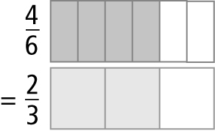
13. a) No b)
14. No. They used of the batter.
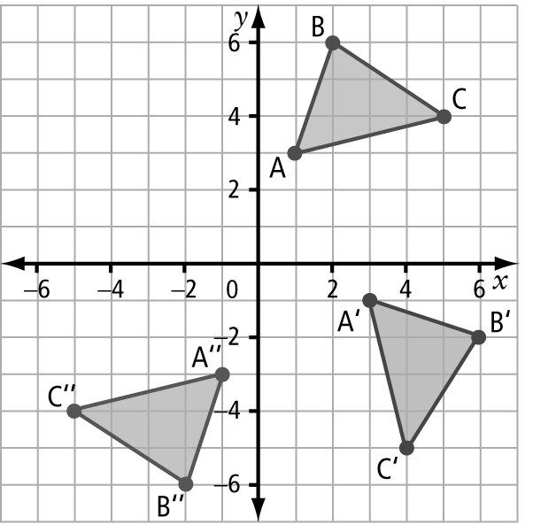
15. a), b)
c)
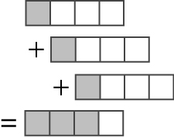
16. . Answers may vary. For example,
17. a) Answers may vary. For example,
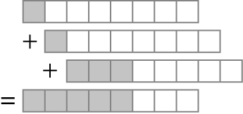
b) Answers may vary. For example,
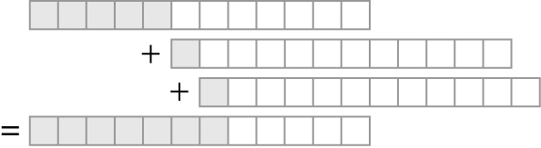
c) . Answers may vary.
and
18. a)
b) No. She has 1 bag of beads bag of beads.

6.3 Subtract Fractions With Like Denominators, pages 220–221
4. a) b) c)
5. a) b) c)
6. a) b)
c)
7. a) b)
c)
8. a) b) c) d) e) f)
9. a) b) c) 0 d) e) f)
10. of the pizza is left.
11. Yes, he will be halfway through because .
12. a) . No. b) She needs of a bag more.
13. and
14. a) No b) He needs of a box more.

Chapter 6 Review, pages 222–223
1. lowest terms 2. divisible
3. common factor
4. |  | 2 | 3 | 4 | 5 | 6 | 8 | 9 | 10
 | 630 | ✔ | ✔ | ✘ | ✔ | ✔ | ✘ | ✔ | ✔
 | 5184 | ✔ | ✔ | ✔ | ✘ | ✔ | ✔ | ✔ | ✘
 | 2035 | ✘ | ✘ | ✘ | ✔ | ✘ | ✘ | ✘ | ✘
 | 810 | ✔ | ✔ | ✘ | ✔ | ✔ | ✘ | ✔ | ✔
5. a) 210 is divisible by 2 because the last digit is an even number, and 210 is divisible by 5 and 10 because the last digit is 0.
b) 1232 is divisible by 4 because 32
is divisible by 2 at least twice, and
1232 is divisible by 8 because 1232
is divisible by 2 at least 3 times.
c) 333 is divisible by 3 and 9 because the sum of the digits is divisible by 3 and 9. 333 is not divisible by 6 because it must be divisible by both 2 and 3 and it is not divisible by 2.
6. Answers may vary.
3 × 5= 15 15 ÷ 3 = 5
2 × 5 = 10 10 ÷ 2 = 5
1 × 5 = 5 5 ÷ 1 = 5
0 × ? = 5 5 ÷ 0 = ?
The pattern shows that there is no number that 0 can be multiplied by that will equal 5. That means that when 5 is divided by 0, there is no possible answer.
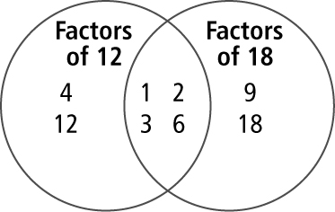
7. a)

The greatest common factor of 12 and 18 is 6.

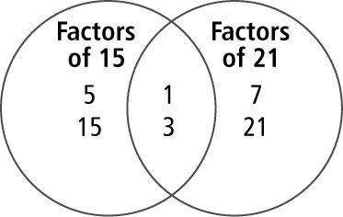
b)

The greatest common factor of 15 and 21 is 3.
8. a) b) c) d) e) f)
9. 6 groups
10. a) b)
c)
11. a) b)
c)
12. a) 1 b) c) d) e) f)
13. Yes,
14. a) b)
15. a) b)
16. a) b) c) 0 d) e) f)
17. a) No. He needs of a jar more.
b) of a jar

Chapter 6 Practice Test, pages 224–225
1. C 2. B 3. C 4. D 5. C
6. The common factors of 54 and 36 are 1, 2, 3, 6, 9, and 18. | 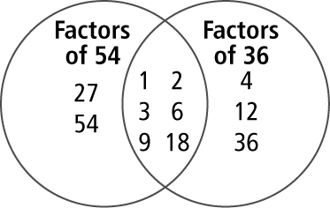
7. a) b) c)
8. a) b)
9. a) b)
10. a) b) 1 c)
11. a) b) c) d)
12. a) of a bag b) of a bag
13. a) No. Jason needs of a can of paint more.
b) of a can
14. Answers may vary. 1248 is divisible by 4 because the number formed by the last two digits of 1248 is divisible by 2 at least twice. 1248 is also divisible by 8 because 1248 is divisible by 2 at least 3 times.
15. a) Mia: b) No.
16. a) No. Ann added the denominators.
b) Answers may vary. For example,
when you add fractions with common denominators, add the numerators and keep the denominator the same.
c)

