Chapter 6 BLM Answers

BLM 6–2 Introduction to Fraction Operations
1. Answers will vary. For example:

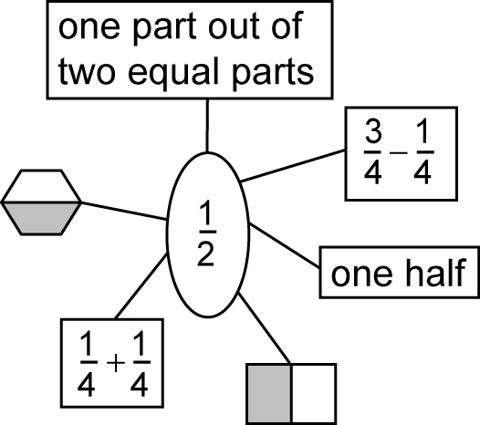

2. a) , 0.25, 25% b) , 0.2, 20%
3. a)
b) Answers may vary. For example:
, , ,
4. Answers may vary. For example:
a) b) c)
5.
6. is larger.
Answers may vary. For example:
1. Fourths are larger parts than fifths.
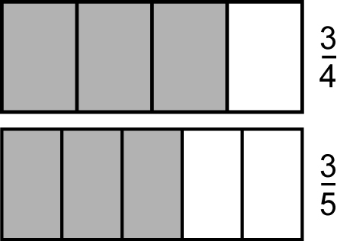
2.

The shaded part showing is larger than the shaded part showing .
7. a) b)

BLM 6–3 Section 6.1 Extra Practice
1. a) 5 b) 9 c) 4 d) 2
e) 8 f) 10 g) 6 h) 3
2. a) 2, 4 b) 2, 3, 4, 6, 8 c) 3, 5
d) 3, 5, 9 e) 2, 3, 4, 5, 6, 8, 10 f) none
3. a) 1, 2, 4 b) 1, 2, 5, 10
c) 1, 2, 3, 4, 6, 12 d) 1, 3, 5, 15

e) 1, 2, 3, 6, 9, 18 f) 1, 2, 4, 5, 10, 20
g) 1, 2, 3, 4, 6, 8, 12, 24
h) 1, 2, 3, 4, 6, 9, 12, 18, 36
4. a) 1, 2, 4 ; 1, 2, 3, 4 , 6, 12; 4
b) 1, 2, 5, 10 ; 1, 2, 4, 5, 10 , 20; 10
c) 12 d) 6 e) 4

BLM 6–5 Section 6.2 Extra Practice
1. a) denominator b) whole c) numerator
d) parts e) size, numerator, denominator

2. a) D b) S c) S
d) D e) D f) D
4 2
3. a) b) c)

4 2

BLM 6–7 Section 6.3 Extra Practice
2

1. a) b)

2
3 6

c) d)

3 6
3

2. a) b) c)

3
3 2 2

d) e) f)

3 2 2

2 5 4

g) h) i)

2 5 4

BLM 6–9 Chapter 6 Test
1. A numerator 2. D divisible
3. C factor 4. E denominator
5. B not possible
6. F written in lowest terms
7. A 8. D 9. C
10. a) b)
11. 12.

13. . Answers may vary. For example:
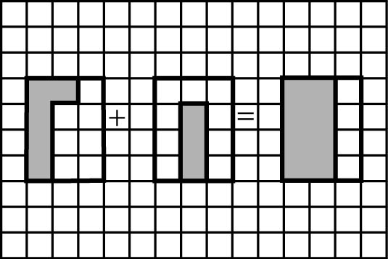

14. Answers will vary. For example: Sean needs of a bag of apples to make a pie. He has of a bag. What fraction
of a bag of apples does he still need? Solution: Sean needs bag of apples.

