Chapter 7 Self-Assessment
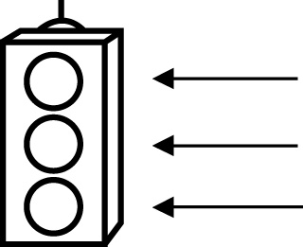 | RED I have not started moving in this area.  YELLOW I am moving along with caution in this area.  GREEN I am moving along confidently in this area.

BEFORE | DURING  (What I can do if I mark yellow or red.) | AFTER  (Proof that I can do this.)
7.1

I can find multiples of a number.
I can find a common denominator using multiples.
I can find a common denominator for a set of fractions.
I can write equivalent fractions.
7.2
I can add fractions with unlike denominators.
I can subtract fractions with unlike denominators.
I can solve problems to do with the addition of fractions with unlike denominators.

I can solve problems to do with the subtraction of fractions with unlike denominators.
I can check my answers.
7.3
I can add mixed numbers with like denominators.
I can add mixed numbers with unlike denominators.
I can solve problems to do with the addition of
mixed numbers.
I can check my answers.
7.4
I can subtract mixed numbers with like denominators.
I can subtract mixed numbers with unlike denominators.
I can solve problems to do with the subtraction of mixed
numbers.
I can check my answers.

