Add and Subtract Fractions
1. Identify all the whole numbers that are
a) between 8 and 12 ____________________________________________
b) between 657 and 660 _________________________________________
c) between 39.2 and 41.9 ________________________________________
d) even and between 2 and 7 _____________________________________
e) multiples of 2 between 488 and 492 ______________________________
f) multiples of 10 between 95 and 125 ______________________________
g) multiples of 6 greater than 58 and less than 70 _____________________

2. Write the fraction shaded in each diagram.

  a)  ____ | 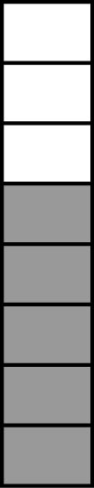  b)  ____ | 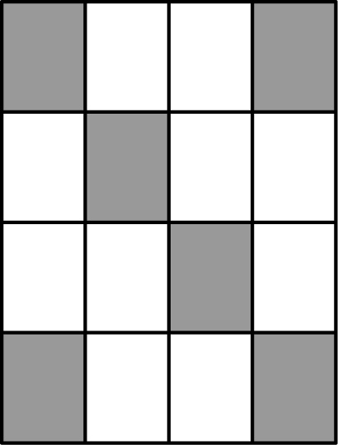  c)  ____

3. Write the fraction shaded in each diagram.

a)
____

b)
____

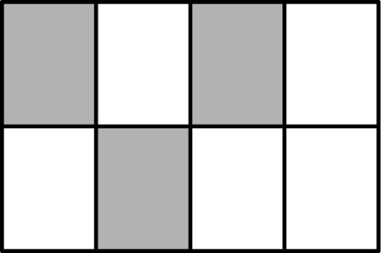
c)

____
4. A fraction has a denominator of 8.
a) What numerator would give it a value close to 1? ____
b) What numerator would give it a value slightly greater than ? ____
c) What numerator would give it a value as little as possible? ____

5. Use the following diagram to answer parts a) and b).
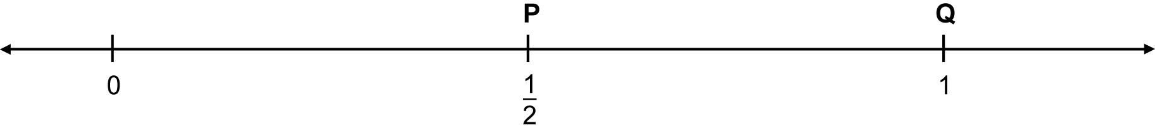
a) List two fractions between P and Q. ____ and ____
b) Identify one fraction between P and Q that has a denominator of 8. ____

6. List the fractions between 0 and that have 8 in the denominator. _______
7. Write the next three fractions in the pattern. ____, ____, ____
8. Which is greater , or ? ____
Explain how you know. __________________________________________

9. A fraction has a denominator of 32.
a) What numerator would give a fraction with a value as little as
possible? ____
- What numerator would give a fraction with a value a little less
than ? ____
- What numerator would give a fraction with a value of ? ____

10. Use the following cards to make fractions of the form that satisfy each
statement below.

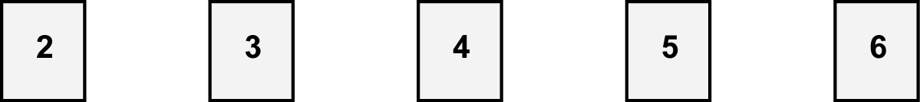

a) Equal to ____ and ____
b) >1 ________________________________________________________

11. a) Which letters on the number line represent proper fractions? _________
b) Which letters on the number line represent mixed fractions? _________

