Section 7.1 Math Link
Use this worksheet to help you with the Math Link on page 236.

1. Determine a common denominator for the fractions in the Eye of Horus.

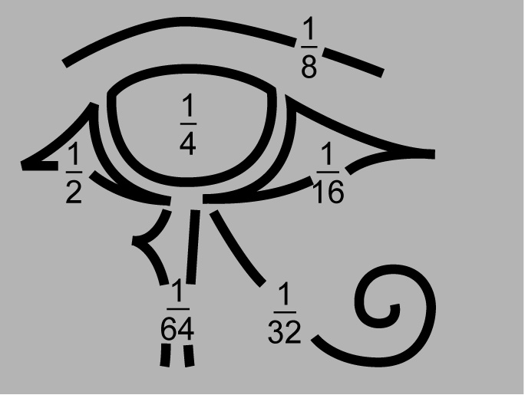

The greatest denominator shown is ____. Now, determine whether this
number is a multiple of the other denominators in the Eye of Horus.

Is this number a multiple of 2? YES NO
Is this number a multiple of 4? YES NO
Is this number a multiple of 8? YES NO
Is this number a multiple of 16? YES NO
Is this number a multiple of 32? YES NO

What did you discover? _____________________________________________

A common denominator for the fractions in the Eye of Horus is ____.

2. Use this common denominator to determine an equivalent fraction for each part in the eye.

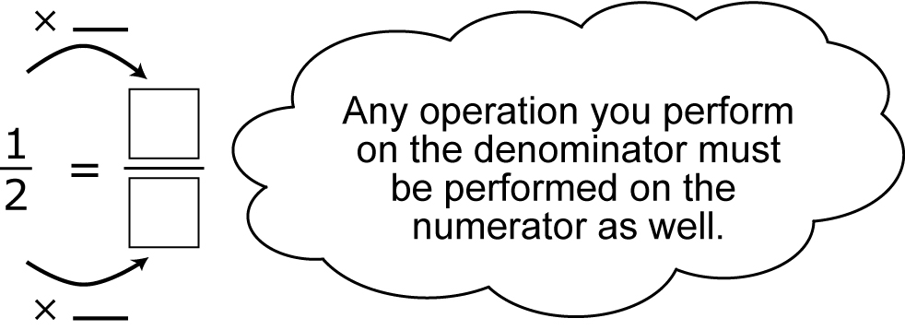
a)

b) c) d) e)

