Section 7.2 Math Link
This worksheet will help you with the Math Link on page 244.
Egyptian fractions use sums of unit fractions to write all other fractions.

A unit fraction has a numerator of ____.

1. Add the unit fractions. Use diagrams to show your work.
Example:

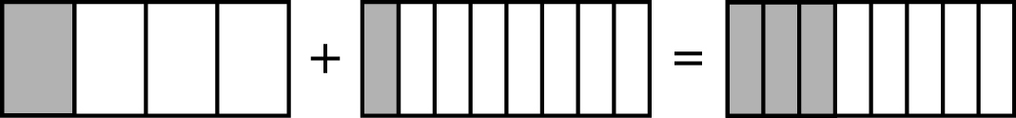

+ =

2. Which sum is greater or ? ____ By how much? ____

3. How would ancient Egyptians have written as the sum of two unit fractions?

= +

Hint: Try subtracting unit fractions from until you have an answer
that is also a unit fraction.

