Chapter 7 Test
For #1 to #5, select the Key Word that completes each statement.
Each Key Word may be used more than once.

1. 6, 12, 18, and 24 are each a(n) ____________ of 6.    2. If one hexagon is one whole, then shows a(n) ____________.  3. For the fractions and , the number 24 is a(n) ____________.  4. is an example of a(n) ____________.  5. is an example of a(n) ____________. | A common denominator  B multiple  C mixed number  D improper fraction

For #6 to #8, select the correct answer.
6. Which number is a common denominator for and ?
A 1 B 10 C 20 D 30

7. What is the sum of the shaded parts in the diagram?


A B C D

8. Which subtraction statement best describes the diagram.

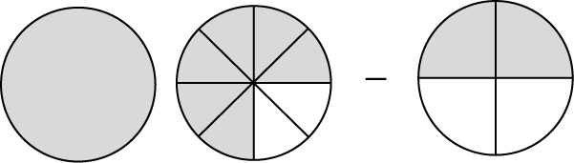
A 1 B C D

Short Answer
9. James is making a salad dressing using cup olive oil and cup vinegar.
He pours the oil and vinegar into a jar. In total, how many cups of dressing does James have?

10. Write a mathematical statement for each diagram. Then, solve. Write each answer in lowest terms.
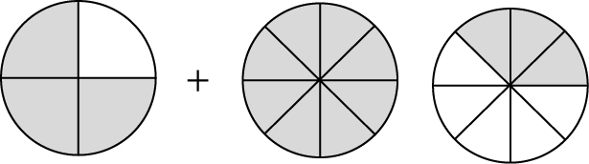
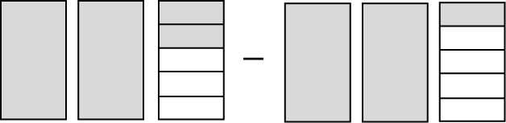
a) b)

11. Add or subtract. Write each answer in lowest terms.
a) b) c) d)

e) f) g) h)

12. Leanne is learning a new dance routine. On Saturday, she rehearsed for
h. On Sunday, she rehearsed for h. How long did Leanne spend rehearsing this weekend?

13. After h, a baseball game was almost over when the score became tied. The extra innings extended the total playing time to h. How long did the extra innings take?

Extended Response
14. Gerry and Raj operate cement-mixing trucks. On Monday morning, they
each had a full truck of cement. By lunch time, Gerry had poured
of his truck’s cement, and Raj had poured of his truck’s cement.
a) Did they pour more or less than a total of one full truck of cement before stopping for lunch?
b) How much cement did each person have in his truck at lunch time?

