Chapter 7 MathLinks 7
Student Resource Answers

7.1 Common Denominators, pages
234–236
4. a) common denominator: 12;
b) common denominator: 8;
5. a) common denominator: 15;
b) common denominator: 24;

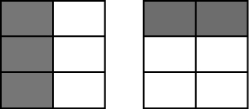
6. a)

common denominator: 6;
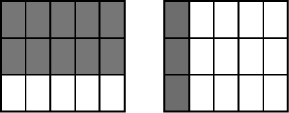
b)

common denominator: 15;
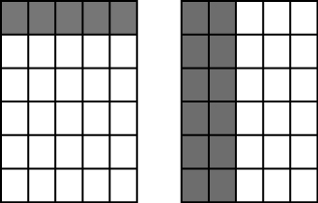
c)

common denominator: 30;
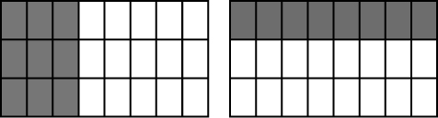
7. a)

common denominator:
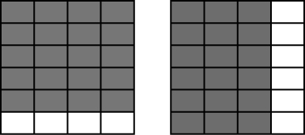
b)

common denominator: 24;
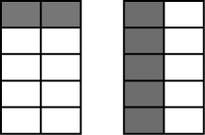
c)

common denominator: 10;
8. a) 10;
b) 12;
c) 24;
9. a) 8; b) 12;
c) 30;
10. a) 16; is larger. b) 49; is larger.
c) 30; is larger. d) 27; the fractions are equal.
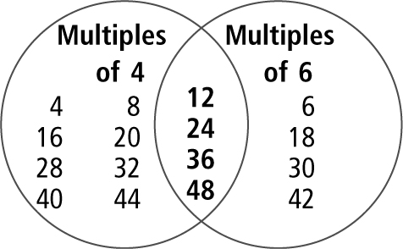
11.

12. a)
b)
c)
d)
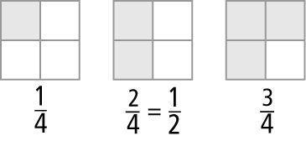
13. a) Answers may vary.
For example,

b) Answers may vary. For example,
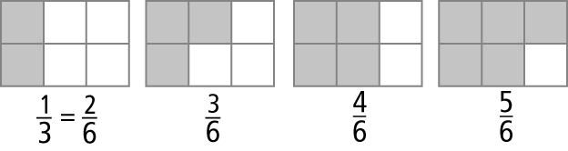
c) Answers may vary. For example,
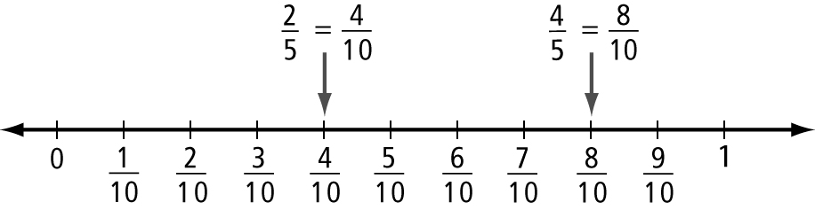
14. 12;
15. a) Answers may vary. of the rectangle is 3 of the 6 squares. of the rectangle is 2 of the 6 squares. The common denominator is 6.
b) common denominator: 28
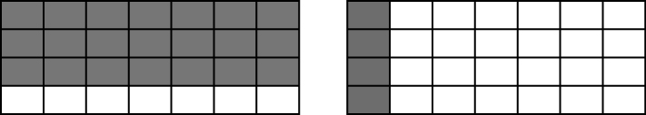
16. a) 36 b) The grass takes up more space.

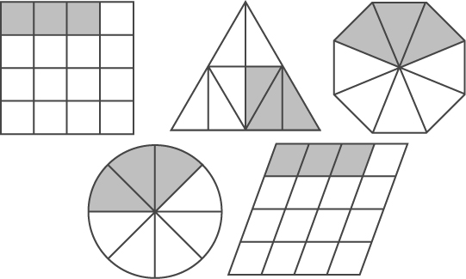
17. a)

b) Answers may vary.
c) Answers may vary.
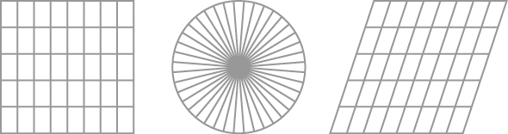
d) Answers may vary.

18.
19. A 20. D
21. a) kindergarten b) grade 5
c) grade 4 and grade 6 d) 360

7.2 Add and Subtract Fractions With Unlike Denominators, pages 242–244
4. Estimates may vary.
a)
b)
c)
5. a)
b)
c)
6. a) b) c) d) e) f)
7. a) b) c) 1 d) e) f)
8. a) b)
9. Estimates may vary.
a)
b)
c)
10. a)
b)
c)
11. a) b) c) d) e) f)
12. a) b) c) d) e) f)
13. a) b)
14. a) of a tray b) or of a tray
15. of a length
16. a) Answers may vary. For example, the friend added the denominators of the fractions. b) Diagrams may vary.
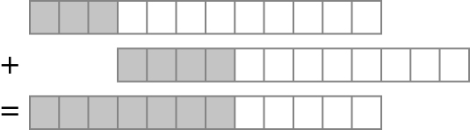
17. or of the plane was left.
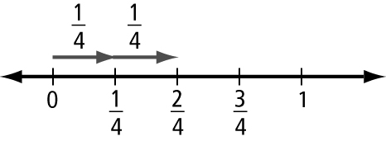
18. a)

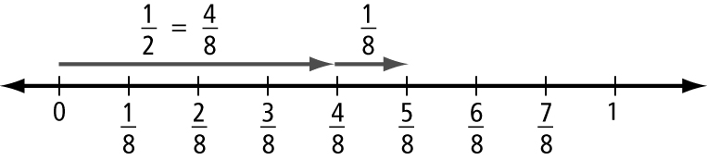
b)

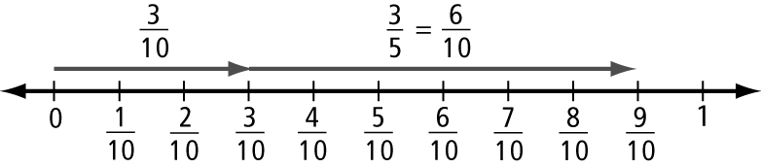
c)

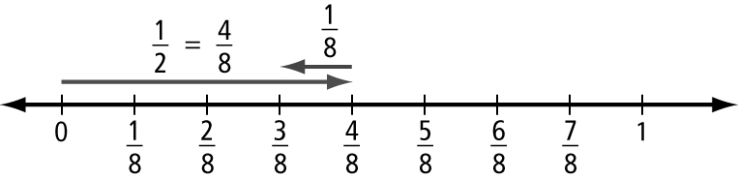
19. a)

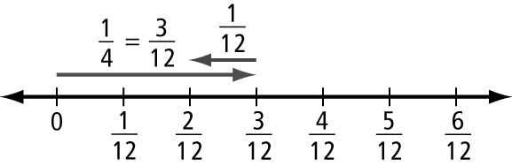
b)

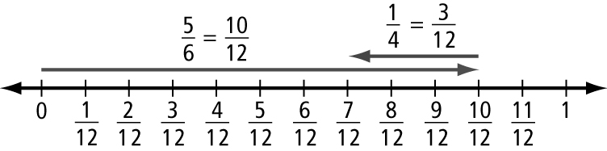
c)

20. No.
=
21. a) full b) 5 h
22.
23. a) B = , C = , D = , E = ,
F = , G =
b) c) d) D and F
e) Answers will vary.

7.3 Add Mixed Numbers, pages 249–251
4. a) b) c)
5. a) b) c)
6. a) b) c) 2
d) e) f)
7. a) b) c)
d) 5 e) f)
8. a) b) c)
9. a) b) c)
10. a) b) c)
d) e) f)
11. a) b) c)
d) e) f)
12. 4 h 13. pages
14. dozen eggs. Estimates may vary.
For example, 2 + 3 = 5 dozen eggs.
15. He cut trays of spinach pie. Diagrams may vary.
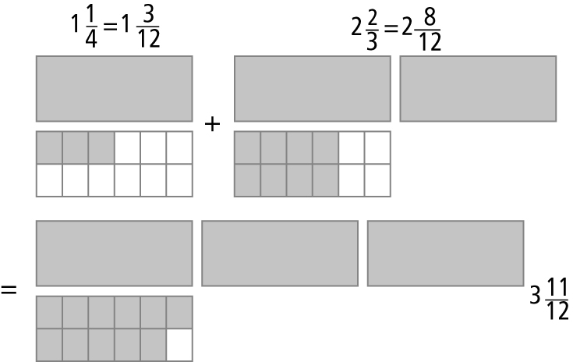
16. h. Estimates may vary. For example, 1 + 1 = 2 h.
17. a) Jonas b) boxes c) boxes
18. a) Answers may vary. 12 h. Yes, she met her goal. b) 11 h c) Answers may vary. Yes, the estimate of 12 h is a little more than 11 h.

19. a) Diagrams may vary.
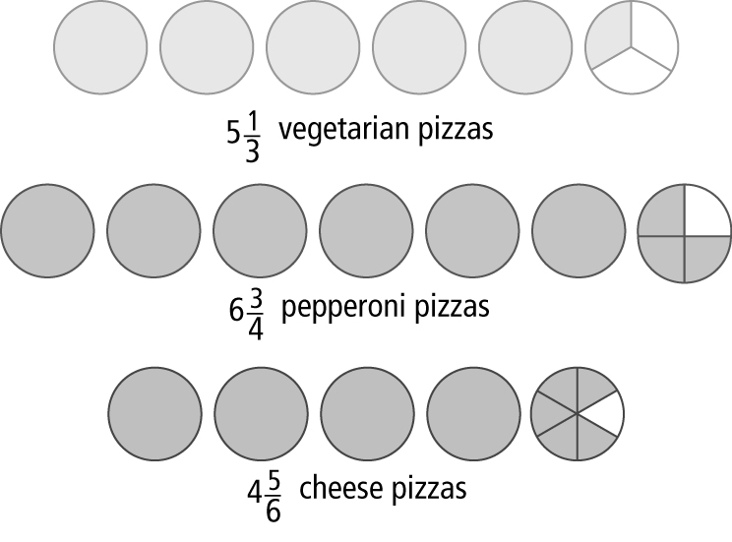
b) Estimates may vary. 17 pizzas. There were pizzas sold.
20. a) h b) p.m.

7.4 Subtract Mixed Numbers, pages
257–259
3. a) b) c)
4. a) b) c)
5. a) b) c) 2 d) e) f)
6. a) b) 0 c) d) e) f)
7. a) b) c)
8. a) b) c)
9. a) b) c)
d) e) f)
10. a) b) c)
d) e) f)
11. h of practice 12. bottles
13. a) h longer b) Answers may vary.
4 − 2 = 2
14. Diagrams may vary.
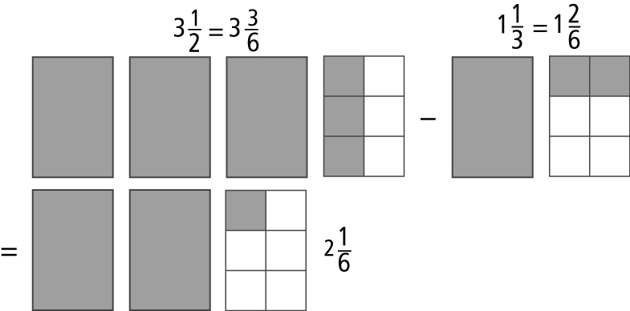
Julia needs more packages of Saskatoon berries.
15. Mark has collected more of a set.
16. a) Alex needs to complete h more.
b) Methods for checking may vary.
17. Mei ran lap farther.
18. a) b) c)
19. Diagrams may vary.
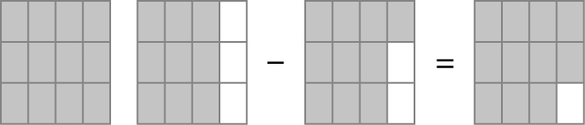
of a tray of dinner rolls is left.
20. a) h b) h c) h
21. a) b) Answers may vary.
22. a) or 0.85 pieces of construction paper
b) or 7.35 pieces of construction paper
23. a) of a package b) 10 golf balls

Chapter 7 Review, pages 260–261
1. multiple 2. improper fraction
3. mixed number 4. common denominator
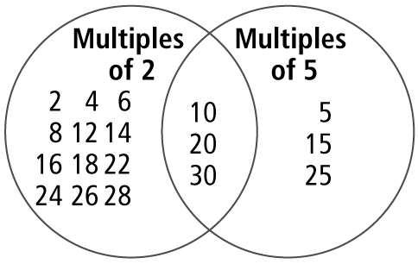
5. a)

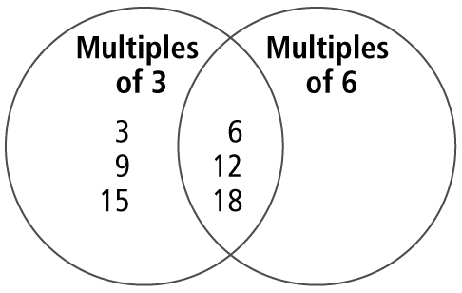
b)

6. Answers may vary.
a) 8 b) 15 c) 12 d) 20
7. common denominator: 12; equivalent fractions: from greatest to least:
8. a)
b)
9. a)
b)
10. a) b) c)
d) e) f)
11. a) b) c) d) e) 0 f)
12. Diagrams may vary.
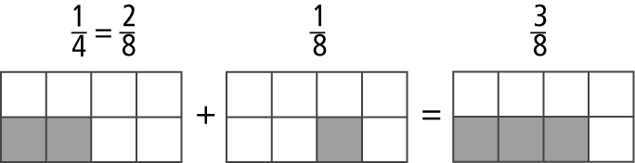
The bin is full.
13. June-el ran h more yesterday. Methods for checking may vary.
14. a) of the bag b) of the bag
15. a) b)
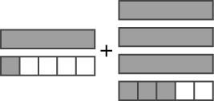
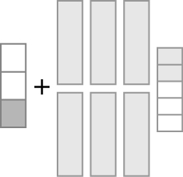
16. a) b)


c)
17. a) b) c)
d) 10 e) f)
18. rooms. Methods of checking may vary.
For example,
19. a) b)
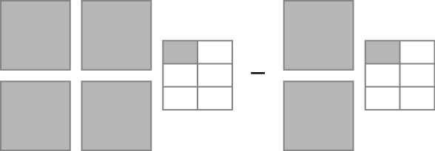
20. a)


b)

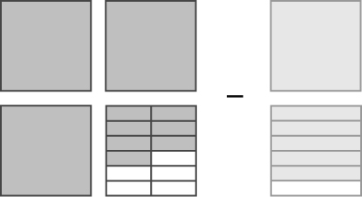
c)

21. a) b) c)
d) e) f)
22. a) of a bag b) bags

Chapter 7 Practice Test, pages 262–263
1. A 2. D 3. D 4. B
5. a) b)
c) d)
6. a) b)
c)
d)
7. a) b) c) 6 d)
8. a) b) c) d)
9. trays
10. a) h b) h
11. a) h b) h
12. a) h
b) Answers may vary.
13. Answers may vary. For example, you need to add or subtract parts of the whole that are the same size.
14. is larger because the diagram is larger. would be larger if the diagrams were the same size.
15. a) Answers may vary. Rowena is correct. She regrouped to .
b)
16. a) of the two rooms is used for Aboriginal peoples.
b) of the two rooms is used for settlement in Canada.
c) more of the two rooms is used for Aboriginal peoples.
d) more of the two rooms is used for settlement in Canada.

