Chapter 8 Self-Assessment
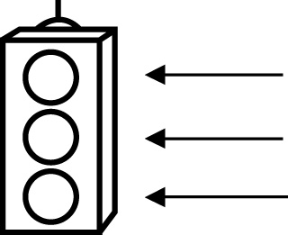 | RED I have not started moving in this area.  YELLOW I am moving along with caution in this area.  GREEN I am moving along confidently in this area.

BEFORE | DURING  (What I can do if I mark yellow or red.) |  | AFTER  (Proof that I can do this.)
8.1

I can draw a circle with a given radius.
I can draw a circle with a given diameter.
I can determine the diameter of a circle given its radius.
I can determine the radius of a circle given its diameter.
8.2
I can estimate and calculate the circumference of a
circle given its
diameter or its radius.
I can solve problems involving the circumference of
circles.

8.3
I can explain how to determine the area of a circle.
I can estimate and calculate the area of a circle.
I can solve problems involving the area of a circle.
8.4
I can read circle graphs.
I can use circle graphs to solve problems.
8.5
I can construct a circle graph with technology.
I can construct a circle graph without technology.

