Perimeter and Area
1. Find the perimeter in centimetres of each figure.

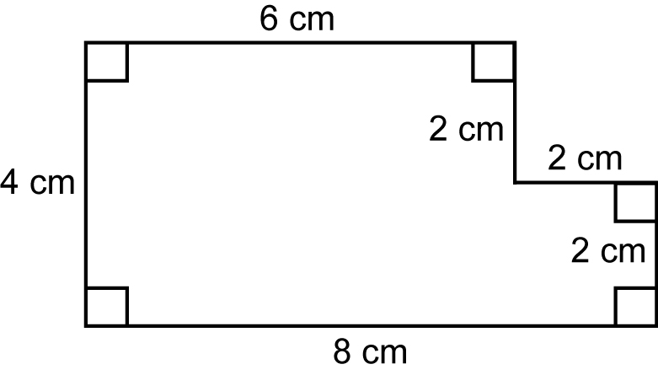  a) | 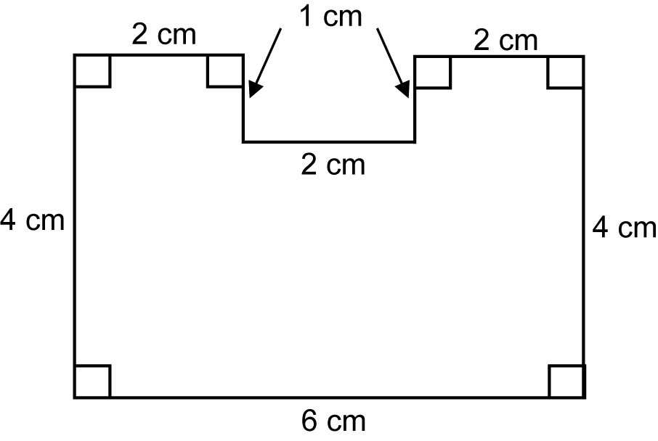  b)

2. In each figure, all angles are right angles. Find the missing lengths for P and Q.

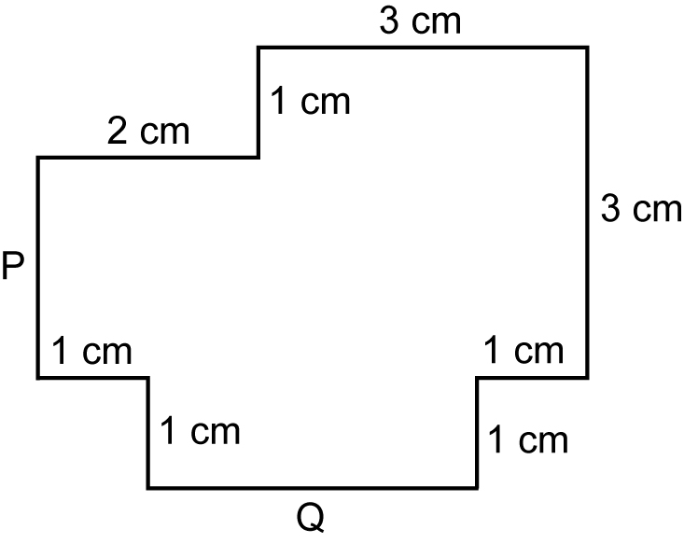  a) | 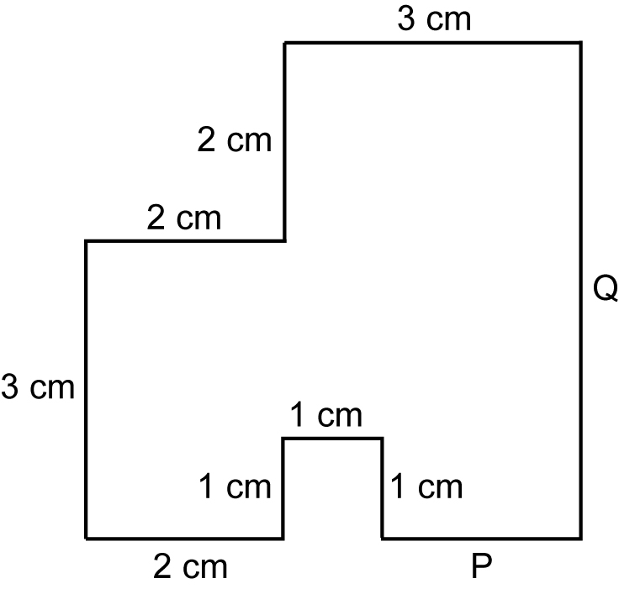  b)

3. Find the area in squares of each figure.

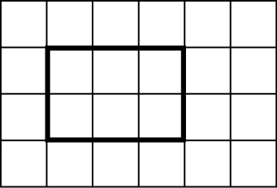  a) | 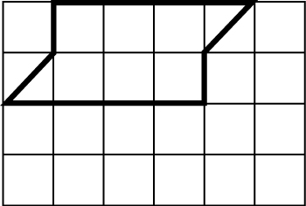  b) | 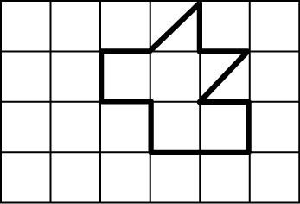  c)

4. Find the area of each figure by counting all the unit squares and half squares.

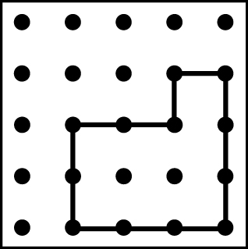  a) | 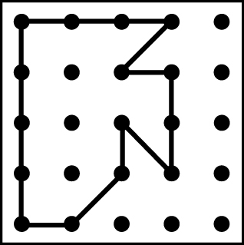  b) | 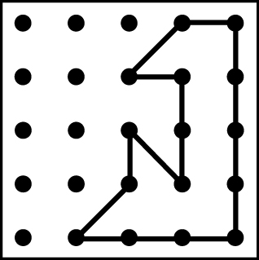  c)
5. Find the perimeter of each shape. Assume that each marked interval is 1 cm.

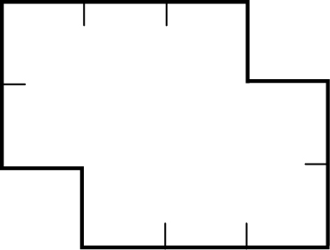  a) | 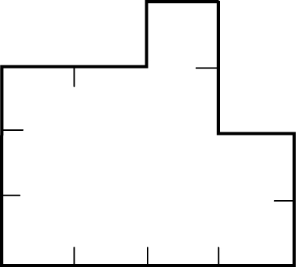  b)

6. Find the area of each shape. Assume that each marked interval is 1 cm.

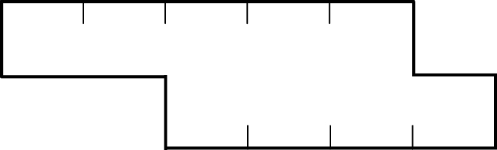  a) | 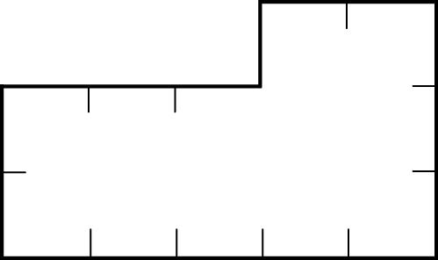  b)

7. Find the perimeter in centimetres.

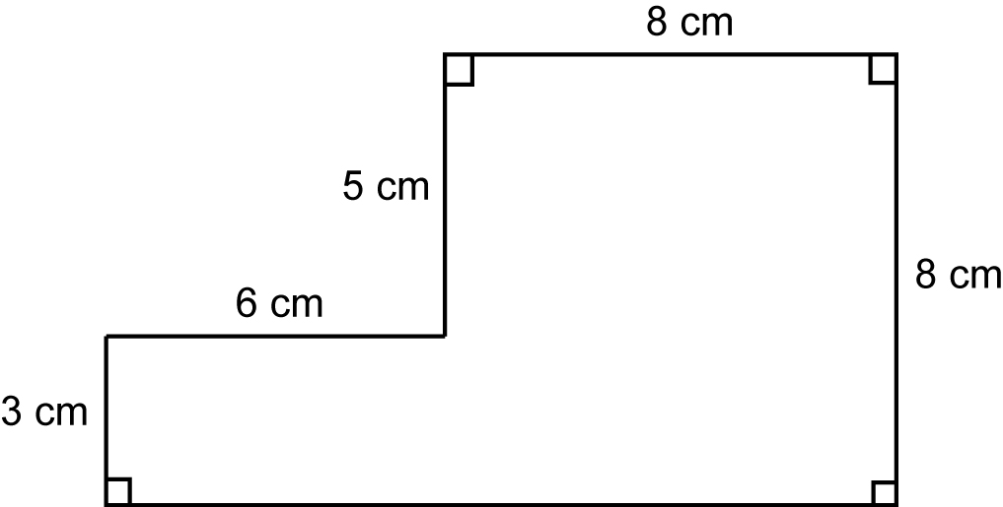

8. Show three different ways to find the area for the shape you see here. All angles are right angles.

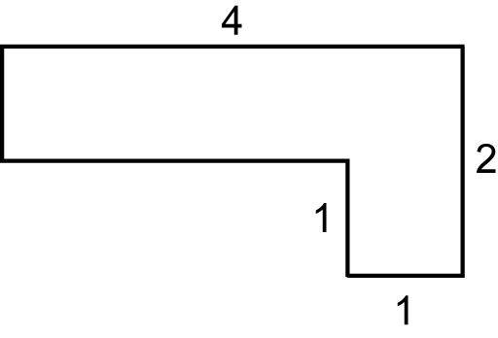

9. a) Which of these shapes has the greatest perimeter? Explain why.
b) Describe how to find the perimeter of shape A.
c) Which shape has the greatest area? How do you know?

