Drawing Circles Using a Computer
and Drawing Software
Instructions for Drawing Circles Using Microsoft Paint®

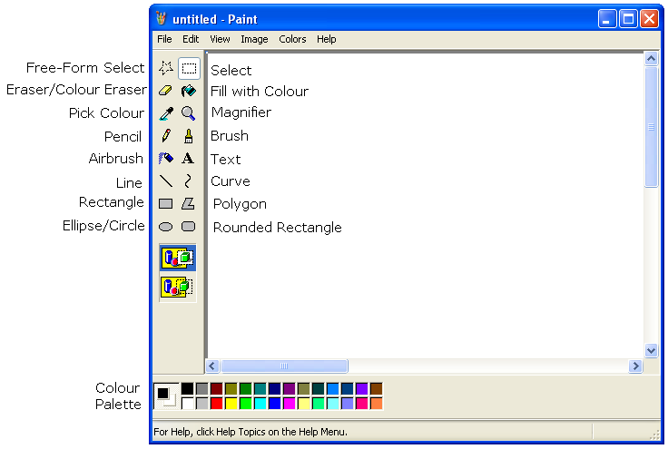
To launch the Paint program:

● Press the Start button.

● Select All Programs.

● Select Accessories.

● Select Paint.

When it opens, the program looks like this.

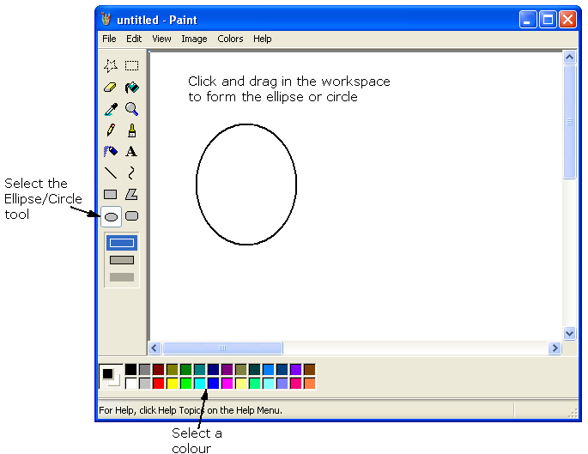
To draw an ellipse or circle:

Select the Ellipse/Circle tool.

Select a colour from the Colour Palette.

Move the cursor to the workspace.

Click and hold the left mouse button.

Drag the mouse until the ellipse or circle is the desired size and shape.

Tech Tip: To draw a perfect circle, press and hold down the SHIFT key while dragging the mouse pointer.
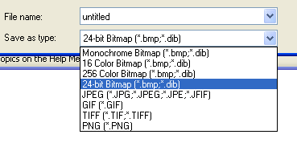
To save your drawing:

Select Save As from the File menu.

Navigate to the desired directory.

Type a file name for your drawing.

Select the format for your drawing. You can save the drawing in different
formats like Bitmap, JPEG, GIF, TIFF,
or PNG.

Tech Tip: If you want high quality files, perhaps for a report or essay, select
24-bit BMP or TIFF. If you want small file sizes, to conserve disk space or to send attached to an email, select JPEG or GIF.

