Section 8.3 Extra Practice
1. Fill in each blank with the correct word. Use the diagram and the word list to help you.

base height radius π × r π × r² r

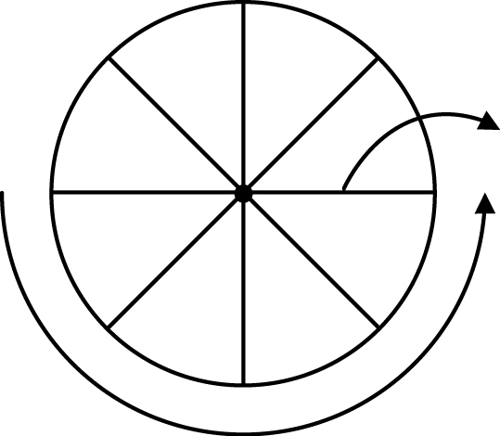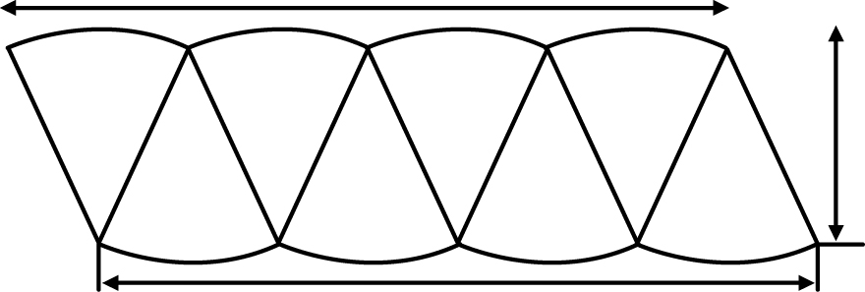

a) The formula for the area of a parallelogram is _______________ × _______________.
b) The circumference of a circle is 2 × π × r. Half of the circumference of a circle is _______________.
c) Half of the circumference of the circle is approximately equal to the length of the _______________ of the parallelogram.
d) The height of the parallelogram is approximately equal to the _______________ of the circle.
e) The area of the parallelogram is the _______________, which is π × r, times the _______________, which is r, so the area of a circle equals __________________________.

2. Complete the table by estimating the missing values. Use 3 as an approximate value for π. The first one is done for you. Hint: Do not use a calculator when estimating.

Radius | Radius Squared | Diameter | Area
20 cm | 400 cm² | 40 cm | 400 cm² × 3 = 1200 cm²
a) 5 cm | ____ cm² | ____ cm | ____ cm²
b) ____ cm | ____ cm² | 16 cm | ____ cm²

3. Use a calculator to help calculate the missing values in the table. Use 3.14 as a value for π. Round all answers to the nearest tenth. The first one is done for you.

Radius | Diameter | Area
35 cm | 70 cm | 35² × 3.14 = 3846.5 cm²
a) 11 cm | ____ cm | ____ cm²
b) ___ cm | 12 cm | ____ cm²

