Section 8.4 Extra Practice
1. The grade 7s in Ms. Turner’s class surveyed all of the grade 7 students in Rocky Mountain Middle School. They wanted to find out which sports the grade 7s most enjoyed playing. The following circle graph shows the survey results. | 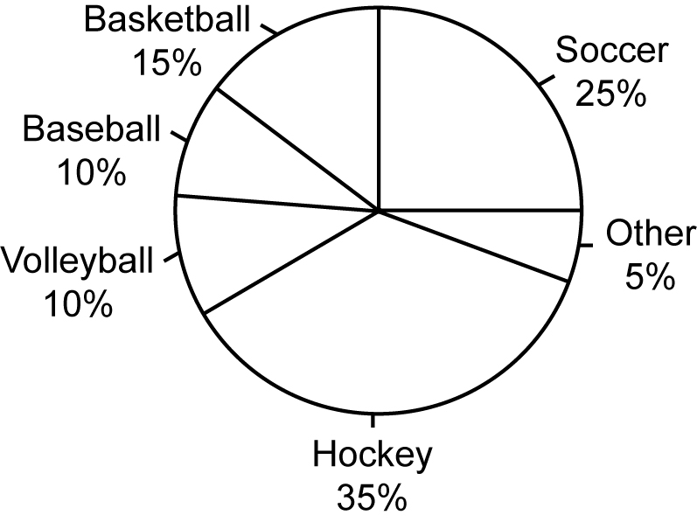

a) List the favourite sports from most popular to least popular.
___________________________________________________________
b) What fraction of the students chose soccer as their favourite sport? Show your work.
___________________________________________________________
c) What percent of the students chose sports that were not listed in the
survey? _____
d) Name two possible sports in the category referred to in c).
_______________ and _______________

2. Rocky Mountain Middle School has 120 grade 7 students. How many students actually chose each sport? Show your work. The first one is started.

Sport | Calculations | Number Who Chose It
a) Hockey | 35% = 0.35 × 120 = _____
b) Soccer
c) Basketball
d) Baseball
e) Volleyball
f) Other

3. a) What should the final column of the chart in #2 add up to? _____. Explain
your thinking. _______________________________________________
___________________________________________________________
b) Add up the final column to check.

