Creating Circle Graphs in Corel®
Quattro® Pro
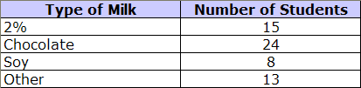
The results of James’ milk survey are shown in the table.

Create a circle graph of these data.

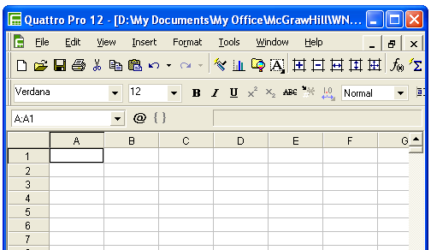
Open Corel® Quattro® Pro.

It looks like this.

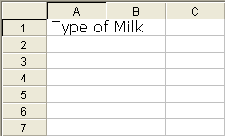
Type “Type of Milk”.

The title will appear in cell A1.

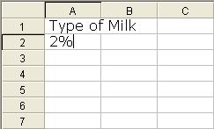
Press the Enter key.

Type “2%”.

The data will appear in cell A2.

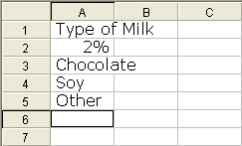
Continue with all data in the Type of Milk list.
When you have finished, column A will
look like this.

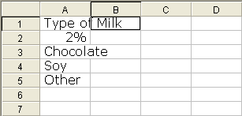
Press the right-arrow key once. Press the
up-arrow key five times.

The outline will be in cell B1. Type “Number of Students”.

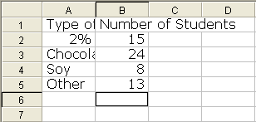
Press the Enter key.

Continue with “15”, and the other data in the "Number of Students" list.

When you have finished, columns A and B
will look like this.

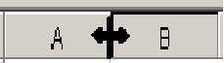
Move the cursor between A and B until the
double arrow shows.

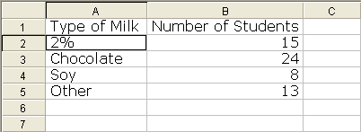
Left-click the mouse, and drag to make column A wider. Adjust the width of column B in the same way.

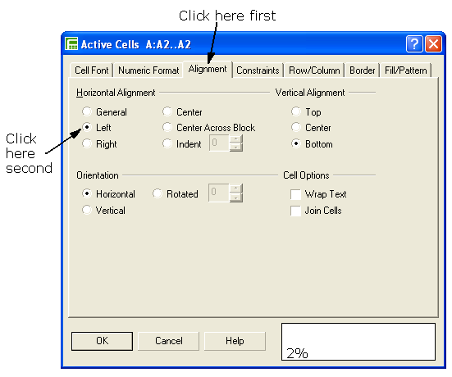
Select cell A2. Select
the Format menu, then Selection Properties,
then Alignment. Set
the horizontal alignment
to Left, and press OK.
Now you can see all
of the data.

Move the cursor to cell A1.  Left-click and drag to B5. | 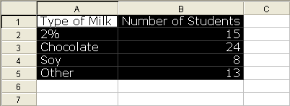

Click on Insert.  Select Chart. | 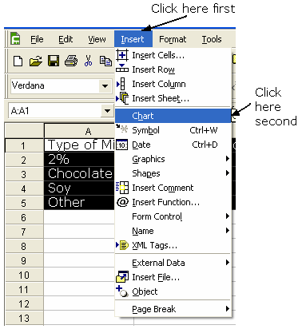
A new box will appear. Click on Next. | 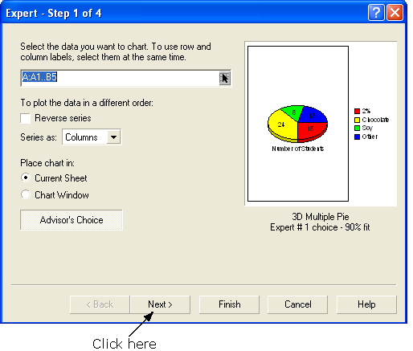

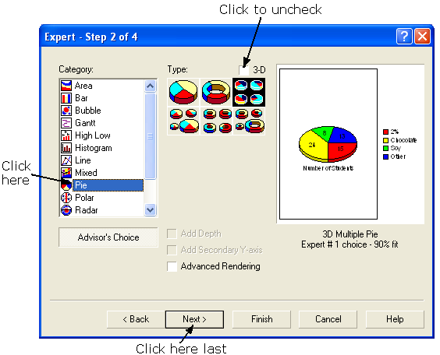
Another box will appear.

Click on Pie.

Click in the 3-D box
to uncheck.

Click Next.

Another box will appear.  Click in the box marked Title.  Type “Milk Survey”.  Press the Tab key twice.  Type “Type of Milk”.  Press the Tab key.  Type “Number of Students”.  Click on Finish. | 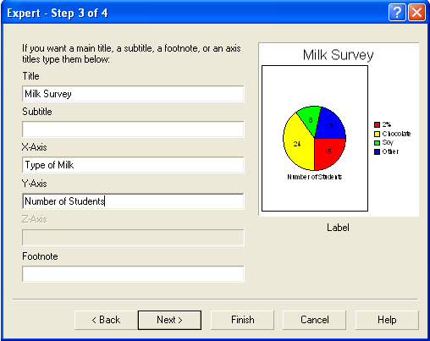

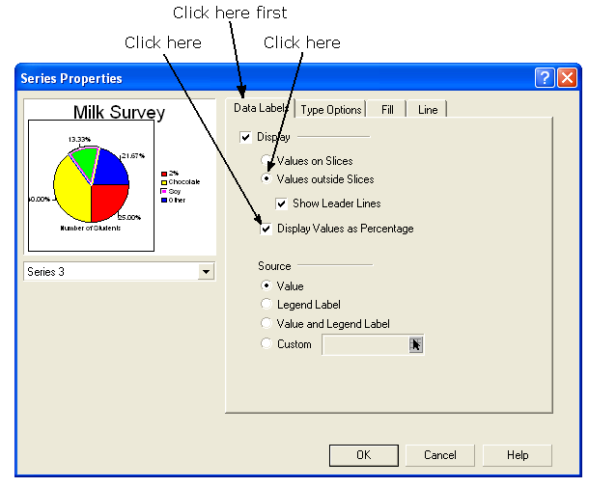

Move the cursor
to a clear space.
Click the left
mouse button.

The circle graph
will appear.

Click on the chart
to select it.

Double-click on one of the slices of the pie. A new box will appear.

Click on the Data Labels tab.

Select the radio button Values outside Slices.

Then, check the box Display Values as Percentage.

Click OK.

Click on the chart to select it.

Double-click on one of the percent values. A new box will appear.

Click on the Numeric Format tab.

Click the down arrow on the Decimal Places spin button twice. This will set the number of decimal places to 0.

Click on OK.
