Creating Circle Graphs in
Appleworks® 6.2
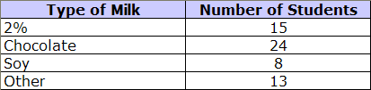
The results of James’ milk survey are shown in the table.

Create a circle graph of these data.

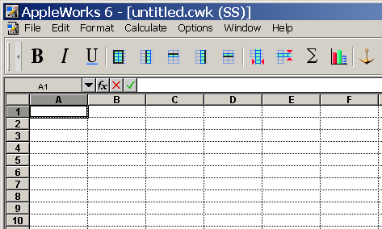
Open Appleworks® 6.2.
It looks like this.

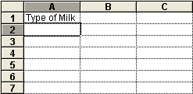
Type “Type of Milk”.

Press the Enter key.

The title will appear in cell A1.

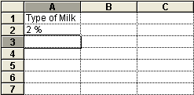
Type “2 %”. (Include a space between the 2 and the %.)

Press the Enter key.

The data will appear in cell A2.
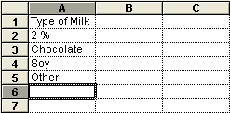
Continue with all data in the “Type of Milk” list.

When you have finished, column A will look like this.

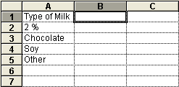
Press the right-arrow key once. Press the
up-arrow key five times.

The outline will be in cell B1. Type “Number of Students”.

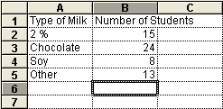
Press the Enter key.

Continue with “15”, and the other data in the
“Number of Students” list.

When you have finished, columns A and B
will look like this.

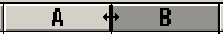
Move the cursor between A and B until
the double arrow shows.

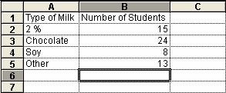
Left-click the mouse, and drag to make column A wider. Adjust the width of column B in the same way.

Now you can see all of the data.

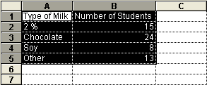
Move the cursor to cell A1. Left-click and
drag to B5.

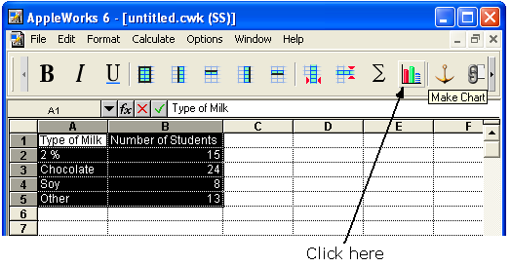
Click on the
Make Chart Wizard.

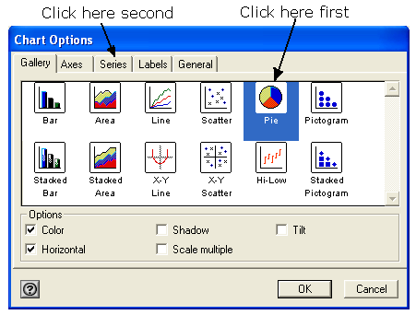
A new box will appear.

Click on the Pie chart.

Click on the Series tab.

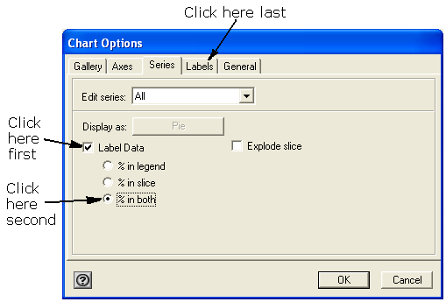
Another box will appear.

Click in the Label Data
box.

Click on the third radio
button.

Click on the Labels tab.

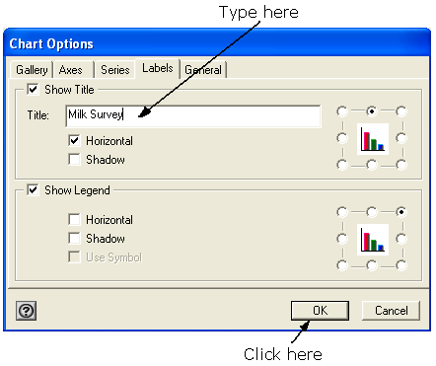
A new box will appear.

Type “Milk Survey”.

Click on OK.

The chart will appear.

