Chapter 8 Test
You will need a ruler and protractor for this test.

For #1 to #6, choose the letter representing the term that best matches each illustration or description. Each letter may be used more than once or not at all.
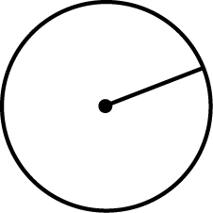
1. ____  2. ____ approximately 3.14:  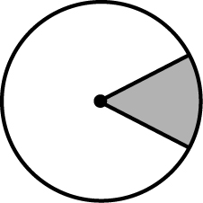  3. ____  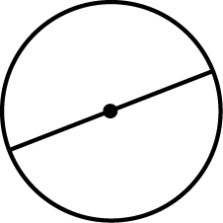  4. ____  5. ____ the distance around a circle:  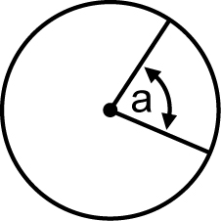  6. ____ | A central angle  B diameter  C radius  D pi  E semi-circle  F sector  G circumference

For #7 to #10, select the best answer.
7. Marcel stands and swings his straightened arm around in a large circle. As he traces out a circle shape, which of the following would be approximately the centre?
A his hand B his elbow C his arm D his shoulder

8. What is the formula for calculating π?
A B
C D

9. What is the formula for calculating the area of a circle?
A Area = 2 × π × r B Area = π × r ²
C Area = 2 × π × r ² D Area = (π × r)²

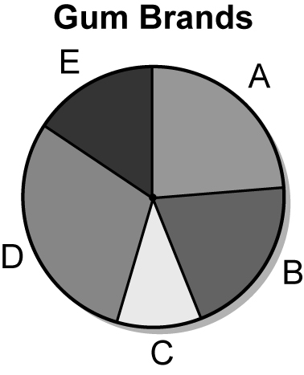
10. On a survey, 420 people were asked for their favourite gum from five different brands. The results are shown in the circle graph.
Which shows the ranking from least to most preferred brand of gum?
A C, E, B, A, D B C, B, A, E, D
C C, E, A, B, D D C, E, B, D, A

Short Answer
For #11 to #14, use a separate piece of paper. Answer to the nearest tenth unless otherwise indicated.
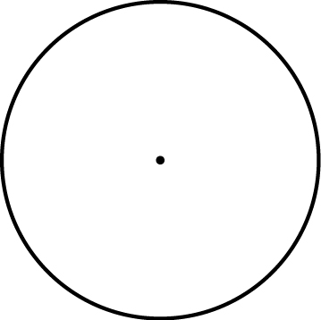
11. What is the circumference of the circle? Round the answer to the nearest tenth.

12. Jana is preparing the area for a circular helicopter-landing zone. The circular zone measures 15 m across. Find the area of the landing zone. Show your work.

13. A school posts the following grades and numbers of students.
a) Complete the following table. b) Complete the circle graph.
Grade | Number of Students | 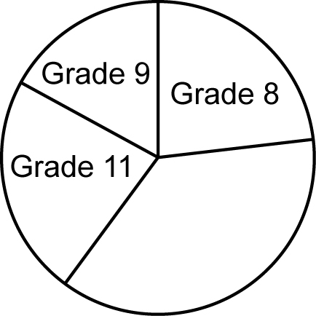  Sector Angle
8 | 300 | 83°
9 | 220 | 60.9°
10 | 280
11 | 300 | 83°
12 | 200
Totals: | 1300

Extended Response
14. You get hired to enclose a circular ice rink with fencing. The diameter of the rink is 20 m. You ask two companies for an estimate. Show all your work.
- “Ice Rinks R Us” estimates $75 per metre. Calculate the total cost.
b) “Rink Builders” estimates $84 per metre. Calculate the total cost.
c) What is the difference in cost?
d) Putting ice in a rink costs $80 per square metre. Calculate the total cost.

