Chapter 8 Wrap It Up!
This worksheet will help you with the Chapter 8 Wrap It Up! on page 301.

Research drum designs from a culture of your choice and design your own similar drum.

Answer the following questions for the drum you design.

1. What is the diameter of the drum? ______

2. How deep is the drum? ______

3. How thick is the material used to make the drum? ______

4. a) Calculate the radius of the top of the drum.

b) Calculate the circumference of the top of the drum.

5. What amount of material do you need to cover the top of the drum?
Hint: Consider any overlap.

6. Draw a design for your drum that includes a variety of circles.

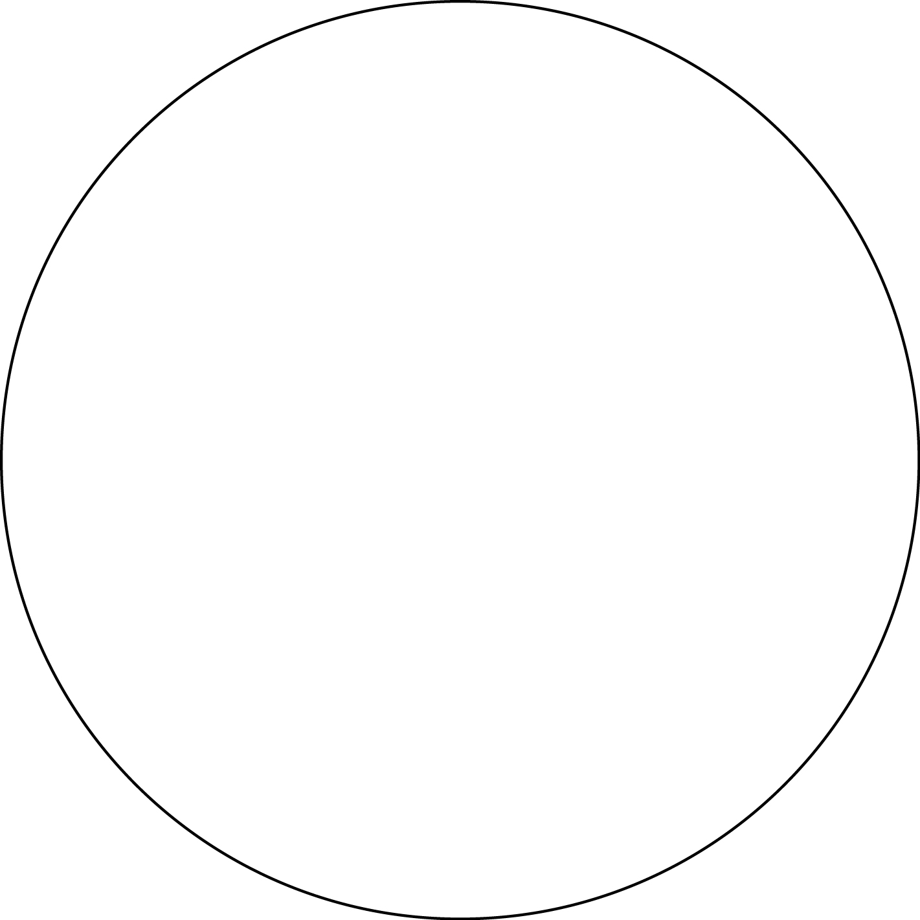

7. Where will you place this design on your drum?

