Chapter 8 MathLinks 7
Student Resource Answers

8.1 Construct Circles, pages 271–272
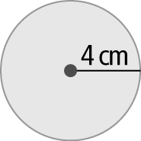
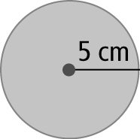
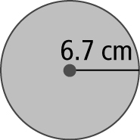
4. a) b) c)
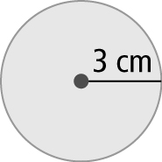
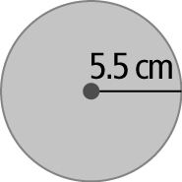
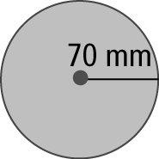
5. a) b) c)
6. a) 10 cm b) 16 cm c) 190 mm
7. a) 2 cm b) 3.5 cm c) 43 mm
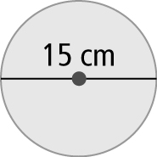
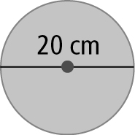
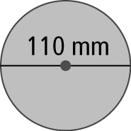
8. a) b) c)
9. a), b) Length AB is the radius of each circle.
10. Circle A is bigger. Circle A has a radius of 25 cm and a diameter of 50 cm. Circle B has a radius of 22.5 cm and a diameter of 45 cm.
11. Always true
12. Designs may vary.
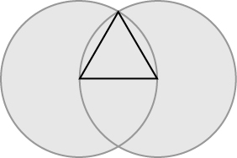  13. | a) triangle  b) Answers will vary. The sides of the triangle are all radii of one or both of the 2 intersecting congruent circles.
14. Answers may vary. 15. Answers may vary.

8.2 Circumference of a Circle,
pages 278–279
3. a) 6 km; 6.6 km b) 3 m; 2.8 m
4. a) 90 mm; 87.9 mm b) 6 cm; 6.3 cm
5. 9 km 6. 41 km
7. a) 6 km; 5.0 km b) 18 m; 17.0 m
8. a) 6 m; 6.3 m b) 120 mm; 125.6 mm
9. 30.1 m 10. 7.5 m
11. 56.5 m 12. 10 frames
13. a) 144.1 m b) 24 cars
14. Always true
15. Answers may vary. Yes. The diameter of the hoop is 0.51 m. The basketballs have
a combined diameter of 0.48 m. 0.51 − 0.48 = 0.03. Therefore, 2 basketballs could fit through the hoop at the same time.
16. Answers may vary. For example: If you use C = π × d, the diameter would equal the circumference divided by pi.
17. a) 70.4 mm b) 27.3 cm
18. 5.7 m 19. approximately 71 more turns

8.3 Area of a Circle, pages 285–286
4. a) 2700 mm²; 3215.4 mm²
b) 3 km²; 1.5 km²
5. a) 675 cm²; 706.5 cm² b) 27 m²; 36.3 m²
6. 113.0 m² 7. a) 1384.7 cm² b) 0.1 m²
8. a) 551.3 cm² b) 0.07 km²
9. a) 171.9 m² b) 314 mm²
10. 510.4 m² 11. 9499 cm² 12. $1059.75
13. 3039.5 cm²
14. Never true. For a circle with radius 5 cm, the area is 78.5 cm². If the radius is doubled to 10 cm, the area of the new circle would be 314 cm². This is 4 times the area of the other circle.
15. 414.48 mm²
16. a) white button: 706.5 cm²; red: 10 977.4 cm²; white: 35 051.9 cm²; blue:
58 419.7 cm²
b) 105 155.5 cm²
17. Yes, if r² = 2r. This will occur when the radius is 2.
18. a)–c) Answers may vary depending on the size of the circles drawn in part a).
d) Answers may vary. The area for the parallelogram is less than the area of the circle. As the circle is divided into even more wedges, the areas will become closer in value.
19. 12.6 cm² 20. 154 m²

8.4 Interpret Circle Graphs, pages
290–291
3. a) grade 7 b) 120 students
c) 30 more students
4. a) 800 books b) 2600 books c) 15%
5. a) walk b) 26 c) 468
6. a) Individual skills
b) Individual Skills, Team Skills, Warm Up, Cool Down; Individual Skills, Scrimmage, Warm Up
c) Warm Up:  6 min Individual Skills: 24 min Team Skills: 12 min Scrimmage: 15 min Cool Down: 3 min | Time | Activity
 | 5:00 p.m. | Warm Up
 | 5:06 p.m. | Individual Skills
 | 5:30 p.m. | Team Skills
 | 5:42 p.m. | Scrimmage
 | 5:57 p.m. | Cool Down
 | 6:00 p.m. | Finish
7. a) Compact b) 8
8. a) Pop b) Ms. Torregrosa’s class
c) Jazz d) Pop, Rock
9. a)–f) Answers may vary.

8.5 Create Circle Graphs, pages 296–297
4. a) | Type | Number of Cards | Percent of Total | Decimal Value Equivalent | Central Angle
 | Forward | 20 | 50% | 0.50 | 180°
 | Defense | 16 | 40% | 0.40 | 144°
 | Goalie | 4 | 10% | 0.10 | 36°
 | Totals | 40 | 100% | 1.00 | 360°
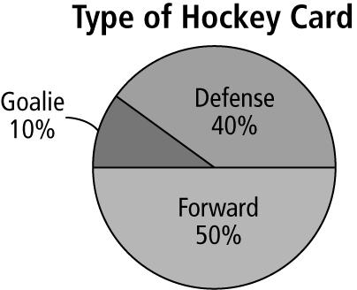
b)
5. a) | Favourite Ice Cream | Number of Students | Percent of Total | Decimal Value Equivalent | Central Angle
 | Chocolate | 24 | 40% | 0.40 | 144°
 | Strawberry | 15 | 25% | 0.25 | 90°
 | Vanilla | 12 | 20% | 0.20 | 72°
 | Other | 9 | 15% | 0.15 | 54°
 | Totals | 60 | 100% | 1.00 | 360°
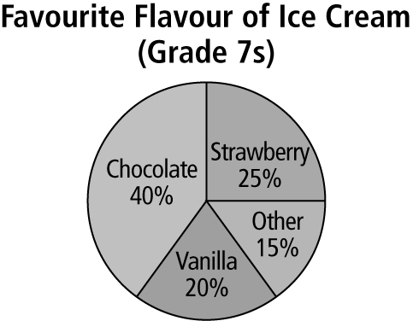
b)

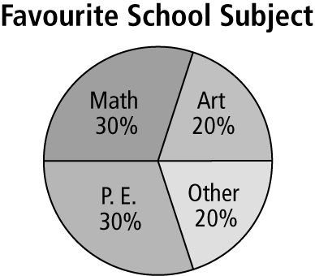
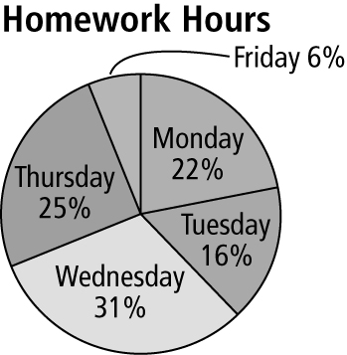
6. 7.
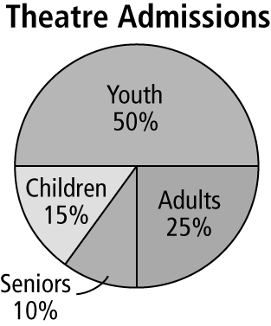
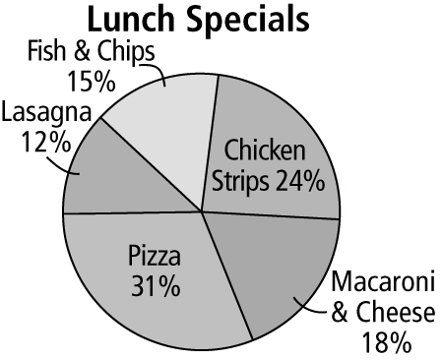
8. 9.
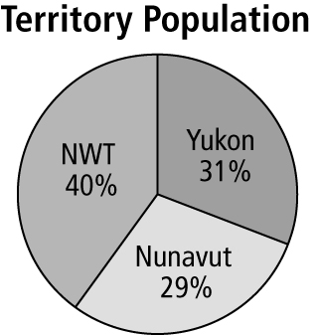  10. a) |  | b) Answers may vary depending on population figures found on Internet.  c) Answers may vary.

11. a)–e) Answers may vary.
12. a)–c) Answers may vary.
13. a)–d) Answers may vary.

Chapter 8 Review, pages 298–299
1. B 2. F 3. A 4. C 5. E 6. D 7. H
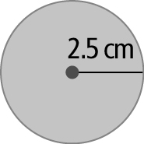
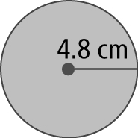
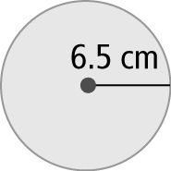
8. a) b) c)
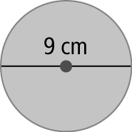
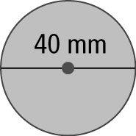
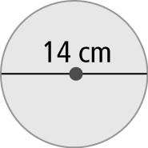
9. a) b) c)
10. No, point B does not lie within the circle.
11. a) 33.9 cm b) 38.3 cm
12. a) 18.8 m b) 5.7 km
c) 4.4 m d) 659.4 cm
13. 3.8 m
14. a) 20.6 m b) $149.35
15. a) 1218.6 cm² b) 221.6 cm²
16. a) 52.8 m² b) 5.3 km²
c) 193.5 m² d) 514.5 mm²
17. 50.2 m² 18. 69.1 cm² 19. 625
20. a) 12 b) 15% c) soccer and baseball

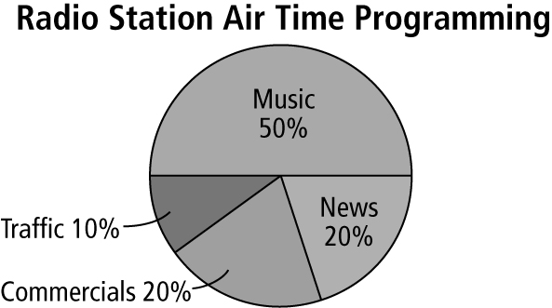
21.
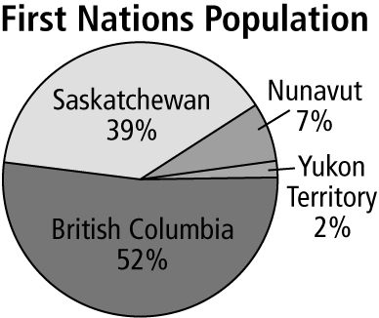  22. a) | b) Answers may vary. The southern provinces have warmer weather and easier access to more resources.

Chapter 8 Practice Test, pages 301–302
1. D 2. C 3. C 4. D 5. 12 cm
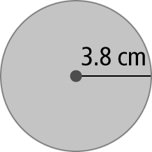
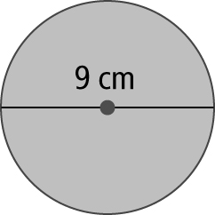
6. 7.

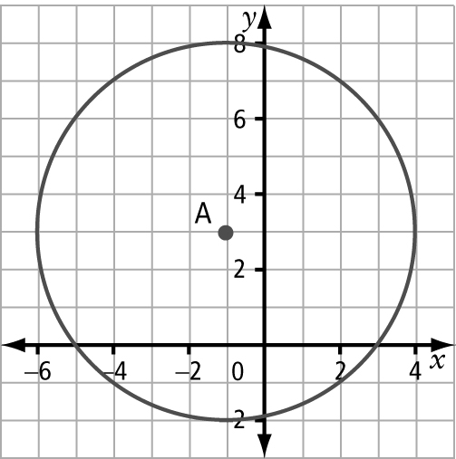  8. | a) radius of the circle  b) 5 cm
9. a) $4.96 b) $1.96
10. 9.1 cm² 11. 18.5 cm²
12. a) Animation
b) Other and Movies and Music; 189
c) Posterific, 11
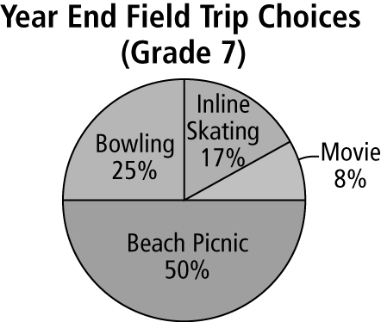  13. a) | b) Movie and Bowling
14. a) 20.56 m b) 6.55 m c) 8.66 m²

15. Answers may vary. No. If the circumference of a circle is 20 cm, then the area of the circle is 31.8 cm². If the circumference is doubled to 40 cm, then the area of the new circle is 127.4 cm². The new area is 127.4 ÷ 31.8 ≈ 4 times larger than the original area, not double the area.

Chapters 5–8 Review, pages 304–306
1. a) or 4:8 or 50% b) or 2:8 or 25%
c) or 0:8 or 0% d) or 8:8 or 100%
2. |  |  | Spinner
 |  |  | 1 | 2 | 3 | 4
 | Coin Toss | Heads (H) | H, 1 | H, 2 | H, 3 | H, 4
 | Coin Toss | Tails (T) | T, 1 | T, 2 | T, 3 | T, 4

3. a) |  |  | Second Letter
 |  |  | a | e | i | o | u
 | First Letter | a | a, a | a, e | a, i | a, o | a, u
 | First Letter | e | e, a | e, e | e, i | e, o | e, u
 | First Letter | i | i, a | i, e | i, i | i, o | i, u
 | First Letter | o | o, a | o, e | o, i | o, o | o, u
 | First Letter | u | u, a | u, e | u, i | u, o | u, u
b) c) d)
4. a) or 13.3% b) or 16.7%
c) Answers may vary. The experimental probability is less than the theoretical probability.
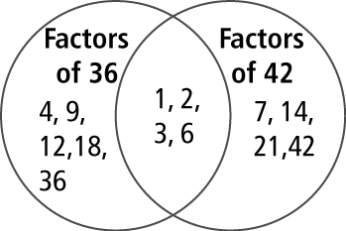
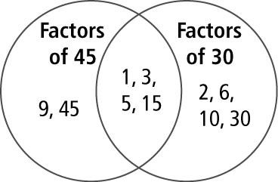
5. a) b)

6. a) b) = 1 c) = 1 d)
7. a) b) 0 c) d)
8. No, she needs another of a bag.
9. a) b) c) d)
10. a) b) c) d)
e) f)
11. a) trays b) of a tray
c) trays
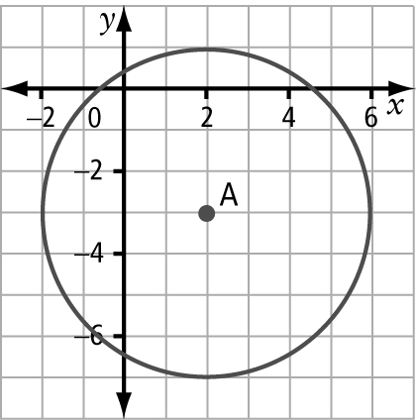  12. a) | b) No
13. a) circumference: 27.0 cm; area: 58.1 cm²
b) circumference: 32.0 cm; area: 81.7 cm²
14. 188.4 cm
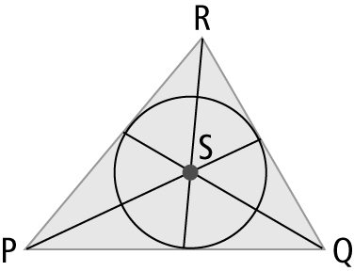
15. a)–c)

16. It is 4 times larger. For example, if r = 5 cm,
A = 78.5 cm². If r = 10 cm, A = 314 cm². 314 ÷ 78.5 = 4
17. a) Scrimmage  b) Scrimmage, Technique, Warm Up; Scrimmage, Drills, Warm Up  c) Warm Up: 6 min; Drills: 15 min; Technique: 15 min; Scrimmage: 21 min; Cool Down: 3 min | Time | Activity
 | 4:00 p.m. | Warm Up
 | 4:06 p.m. | Drills
 | 4:21 p.m. | Technique
 | 4:36 p.m. | Scrimmage
 | 4:57 p.m. | Cool Down
 | 5:00 p.m. | Finish
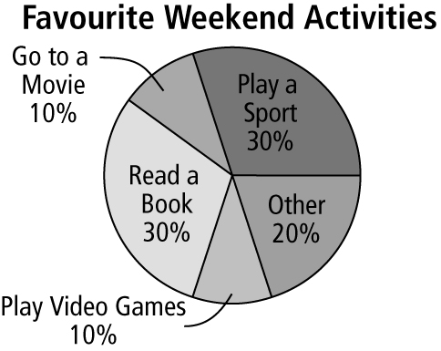
18.

