Chapter 8 BLM Answers

BLM 8–3 Perimeter and Area
1. a) 24 cm b) 22 cm
2. a) P = 2 cm; Q = 3 cm
b) P = 2 cm; Q = 5 cm
3. a) 6 squares
b) 7 squares
c) 5 squares
4. a) 7 squares
b) 9.5 squares
c) 6.5 squares
5. a) 14 cm b) 16 cm
6. a) 9 cm² b) 12 cm²
7. 44 cm
8. Answers will vary. For example: Count 4 squares in top row and add 1 square in bottom row. Divide into 2 rectangles and count 3 in horizontal rectangle and 2 in vertical rectangle. Make one large rectangle of 8 squares and subtract
3 squares.
9. a) C. Answers will vary. For example:
C has the most fingers.
b) Answers will vary. For example:
Measure the length of one finger and
multiply by 8.
c) B. Answers will vary. For example: B is
a full circle. A and C may have the
same diameter but have missing
pieces.

BLM 8–6 Section 8.1 Extra Practice
1. a) centre, radius, r
b) diameter, d
c) diameter, radius
2. Look for three concentric circles with different diameters: 4, 5, and 3 cm.

BLM 8–8 Section 8.2 Extra Practice
1. a) circumference, C b) diameter, radius
c) multiplying d) dividing
2. a) 10.4 b) 6.2
c) 137.5 d) 3045.1
3. Answers are in italics.
a) 22.2, 44.4, 139.4
b) 38.5, 77, 241.8
c) 17.9, 35.7, 112
d) 237, 474, 1488.4

BLM 8–10 Section 8.3 Extra Practice
1. a) base, height b) π × r c) base
d) radius e) base, height, π × r × r = π × r ²
2. Answers are in italics.
a) 5, 25, 10, 75 b) 8, 64, 16, 192
3. Answers are in italics.
a) 11, 22, 379.9 b) 6, 12, 113.0

BLM 8–12 Section 8.4 Extra Practice
1. a) Hockey, soccer, basketball, baseball,
volleyball. (Baseball and volleyball
tied.)
b) 25% = =
c) 5%
d) Look for any two sports not surveyed.
2. a) Hockey, 35% = 0.35 × 120 = 42
b) Soccer, 25% = 0.25 × 120 = 30
c) Basketball, 15% = 0.15 × 120 = 18
d) Baseball, 10% = 0.10 × 120 = 12
e) Volleyball, 10% = 0.10 × 120 = 12
f) Other, 5% = 0.05 × 120 = 6
3. a) 120. The numbers in a circle graph
need to add up to 100% of the total.
b) The final column should add up to 120.

BLM 8–17 Section 8.5 Extra Practice
1. a) Answers are in italics.
6 + 11 + 5 + 2 + 1 = 25, 25
b) 2, 11, , 44%, 0.44, 0.44 × 360° = 158°
3, 5, , 20%, 0.2, 0.2 × 360° = 72°
4, 2, , 8%, 0.08, 0.08 × 360° = 29°
5 or more, 1, , 4%, 0.04, 0.04 ×
360° = 14°
Totals: 25, 100%, 1.00, 359°
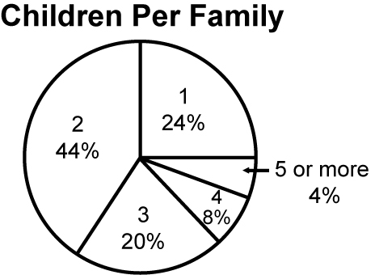
c)

BLM 8–18 Chapter 8 Test
1. C 2. D 3. F 4. B 5. G 6. A 7. B
8. D 9. B 10. A 11. 9.4 cm
12. A = π × r ²
A = π × 7.5²
A ≈ 176.6 m²
13. a) Answers are in italics.
10, 280, 77.5°
12, 200, 55.4°
b) Students should use a protractor to
make sectors for Grades 10 (77.5°)
and 12 (55.4°).
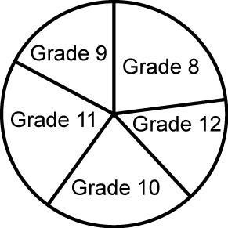

14. a) C = π × d
3.14 × 20 m = 62.8 m
62.8 m × $75 = $4710
b) 62.8 m × $84= $5275.20
c) $565.20
d) A = π × r ²
3.14 × 100 = 314 m²
314 m² × $80 = $25 120

