Chapter 9 Self-Assessment
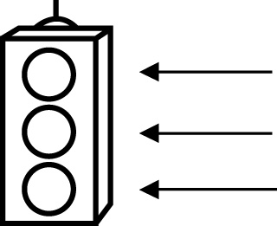 | RED I have not started moving in this area.  YELLOW I am moving along with caution in this area.  GREEN I am moving along confidently in this area.

BEFORE | DURING  (What I can do if I mark yellow or red.) | AFTER  (Proof that I can do this.)
9.1

I can add integers using integer chips.
9.2
I can add integers using a number line.
9.3
I can subtract integers using integer chips.
9.4
I can use addition to subtract integers.
9.5
I can decide when to add and subtract integers in solving problems.

