Adding and Subtracting Integers
1. Identify all of the integers
a) between +8 and +12 _______________
b) between –657 and –653 _______________
c) between –39.2 and –40.9 ______________________________________
___________________________________________________________

2. a) Choose one of these integers: –5, –4, –3, or –2.
b) Print the integer in the centre of a piece of paper.
c) Represent the integer at least six different ways. Use words, symbols, operations, and diagrams.

3. Use <, >, or = to make each statement true.
a) +854 ____ –855
b) –855____ –854

4. Arrange the following integers in descending order (from greatest to least).
a) –1, –6, –2 _______________
b) –369, +356, –365 _______________

5. Each card contains one integer. What is the largest number you can make using only two cards?

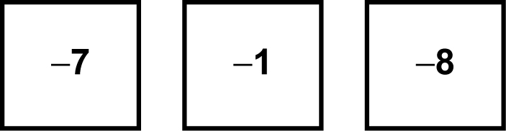

6. Arrange the following integers in ascending order (from least to greatest).
a) –109, –129, +99.4, +99.41 __________________
b) –8.1, 0, +2.5, –6.2 __________________

