Section 9.1 Extra Practice
1. What addition statement do the integers in the diagram represent? Explain your reasoning.

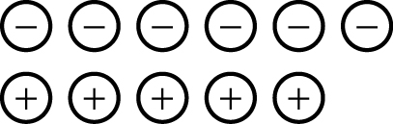

2. Use the sum of two integers to represent each situation.
Example: Jean was given $12 then spent $5. How much did she have left?
(+12) + (–5) = +7
Jean has $7 left.

a) Marianne was given $17 then spent $11. How much money did she have left?

b) In the morning it was –5°C. In the afternoon the temperature went up by 7°C. What was the temperature in the afternoon?

c) In a hockey tournament, Jeremy’s team scored 7 goals and had 8 goals scored against it. How many goals did Jeremy’s team lose by?

d) From a 10 m platform, Amy dove 14 m. What was her depth under the water?

For #3 to #5, copy and answer each question.
3. Complete each addition statement. Use integer chips to help you.
Example: (+6) + (–6) = 0

a) (+3) + (____) = 0 b) (____) + (–7) = 0
c) (+8) + (____) = 0 d) (____) + (–10) = 0

4. Write “P” if the sum is positive. Write “N” if the sum is negative.
Example: (–7) + (+1) = N

a) (+6) + (–5) = ____ b) (+6) + (–9) = ____
c) (–6) + (–4) = ____ d) (+6) + (–2) = ____

5. What is each sum? Use integer chips to help determine your answers.

a) (–7) + (+1) + (+2) = ____ b) (–2) + (–4) + (+3) = ____
c) (+5) + (+3) + (–1) + (−4) = ____ d) (–4) + (+3) + (–2) + (–6) = ____

