Section 9.3 Extra Practice
1. Calculate each difference by drawing and colouring integer chips. Then write each subtraction statement and the answer.
• Use red chips to represent positive integers.
• Use blue chips to represent negative integers.

Example: 9 negative chips – 4 positive chips = 13 negative chips

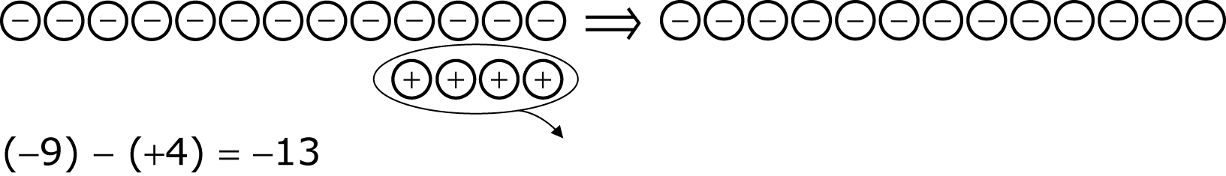

a) 7 blue chips – 4 red chips = ____________________

b) 8 red chips – 3 blue chips = ____________________

c) 13 red chips – 7 blue chips = ____________________

2. For each question:
• Write the number of zero pairs you will need to add.
• Write the subtraction statement. Then find the difference.

Question | Number of Chips | Subtraction Statement
Example: 8 blue chips – 5 red chips | I will need 5 zero pairs. | (–8) – (+5) = (–13)
a) 7 red chips – 2 blue chips
b) 7 blue chips – 2 red chips
c) 9 blue chips – 5 red chips
d) 8 red chips – 9 blue chips
e) 5 red chips – 7 red chips

