Faces
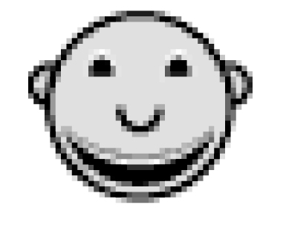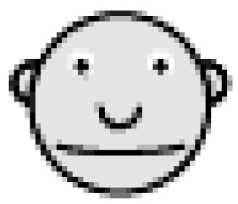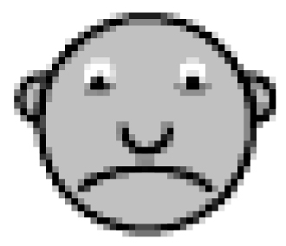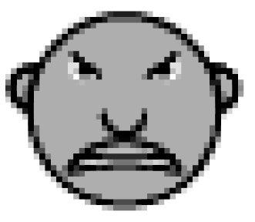
happy face neutral face sad face angry face

+7 | +7 | +7 | +7 | +7
0 | 0 | 0 | 0 | 0
–4 | –4 | –4 | –4 | –4
–10 | –10 | –10 | –10 | –10

