Chapter 9 Test
NO CALCULATORS FOR THIS TEST

For #1 to #5, select the best answer.

1. Which addition does the diagram represent?

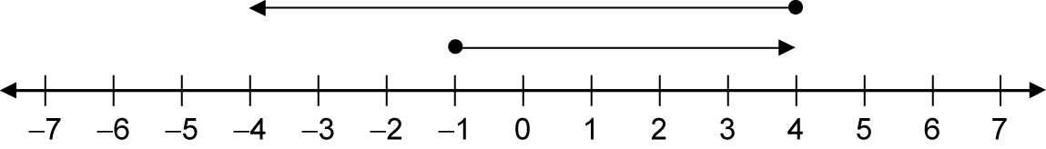

A (–5) + (+8) B (+5) + (–8) C (–8) + (+5) D (+5) + (+8)

2. Which diagram best represents two negative integers being added together?

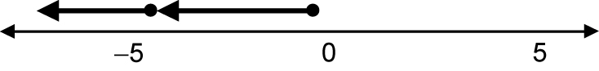
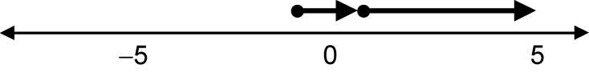
A B

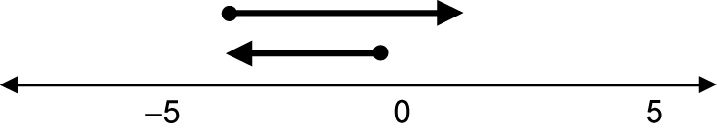
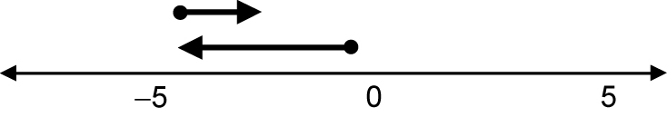
C D

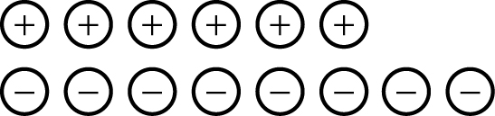
3. What is the final value?

A +2 B –2 C +14 D –14

4. Which shows the correct changes to find the answer for (−7) − (−12)?
A (+7) + (–12) B (–7) + (–12) C (–7) + (+12) D (+7) – (+12)

5. Tracey uses integer chips to represent (–3) – (–5). She starts with three negative chips and then adds more chips to prepare for the subtraction. Which one of the following represents this step?
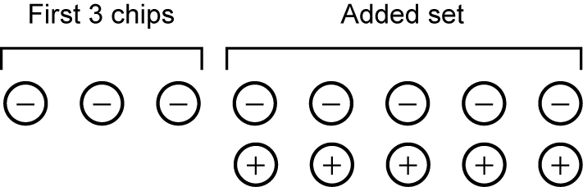
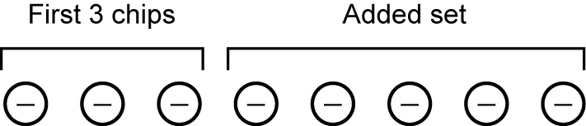
A B

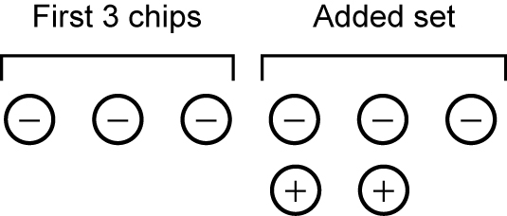
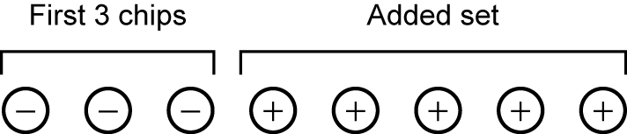
C D

Short Answer
For #6 to #8, use a separate piece of paper.
6. A bird flies above the water at a height of 35 m. A fish swimming directly underneath the bird is 9 m below the surface of the water. Calculate the distance between the bird and the fish. Show all your work.

7. At noon, Jake checked the temperature and found that it was –7°C. By the late afternoon, the temperature had dropped 8°C. What is the temperature in the late afternoon? Show all your work.

8. What is each sum or difference?
a) (–12) + (+7) d) (–6) + (–9)
b) (+5) – (–8) e) (+8) – (+15)
c) (–4) – (+9) f) (+12) + (–10)

Extended Response
9. Determine the perimeter and area of the figure with vertices at
(–11, +7), (–11, –4), (+6, +7), and (+6, –4). Show all of your work.

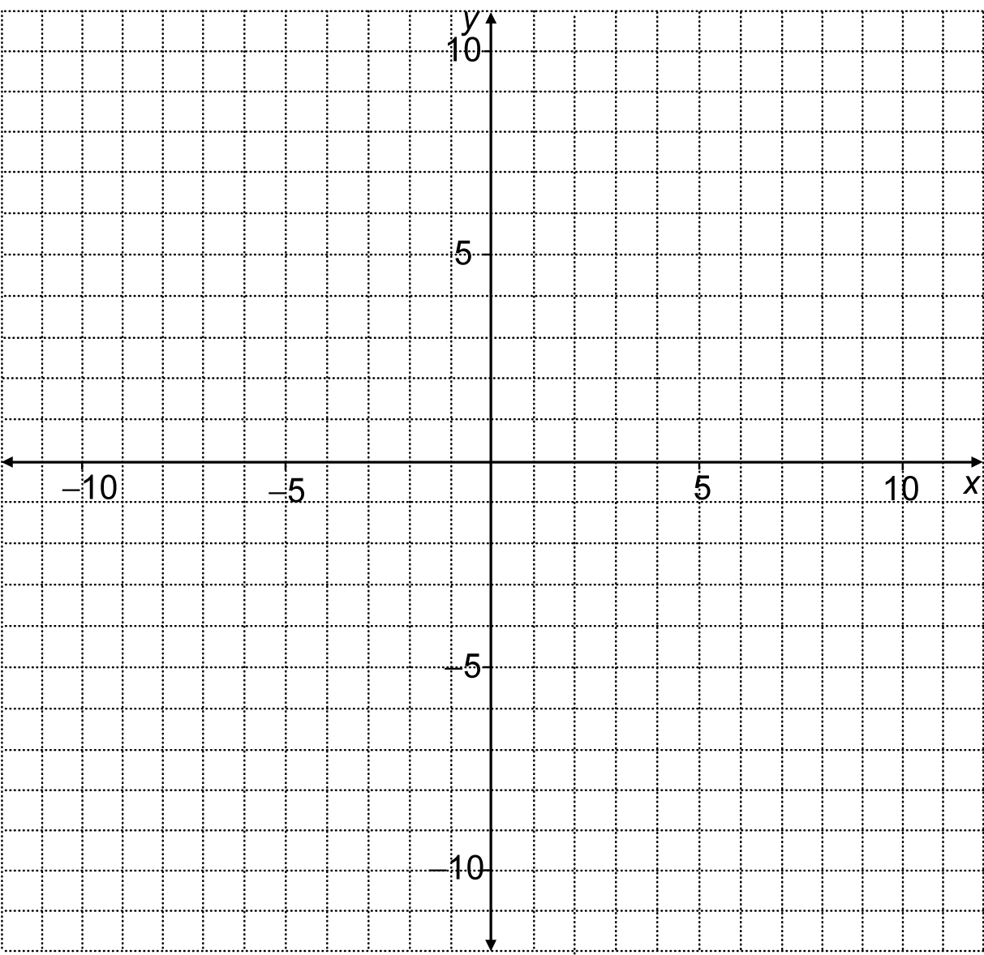

10. On a piece of paper, make up four different expressions that have (–3) as an answer. Make two addition statements and two subtraction statements.

