Chapter 1 Self-Assessment
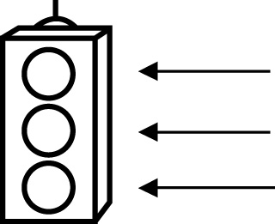 | RED I have not started moving in this area.  YELLOW I am moving along with caution in this area.  GREEN I am moving along confidently in this area.

BEFORE | DURING  (What I can do if I mark yellow or red.) | AFTER  (Proof that I can do this.)
1.1
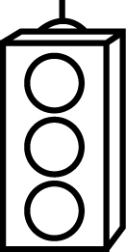
I can label the axes of a Cartesian plane.
I can label the origin of a Cartesian plane.
I can identify points on a Cartesian plane.
I can plot points on a Cartesian plane.
1.2
I can create a design on a Cartesian plane.
I can identify the points used to make a design.
I can identify the coordinates of vertices of a 2-D
shape.

1.3
I can use a translation.
I can use a reflection.
I can use a
rotation.
I can describe the image resulting from a transformation.
1.4
I can describe the movement of a point on a Cartesian plane using the terms
horizontal and
vertical.
I can determine the horizontal distance between two points.
I can determine the vertical distance between two points.
I can determine how the vertices of a 2-D shape change
position when they are transformed
one or more times.

